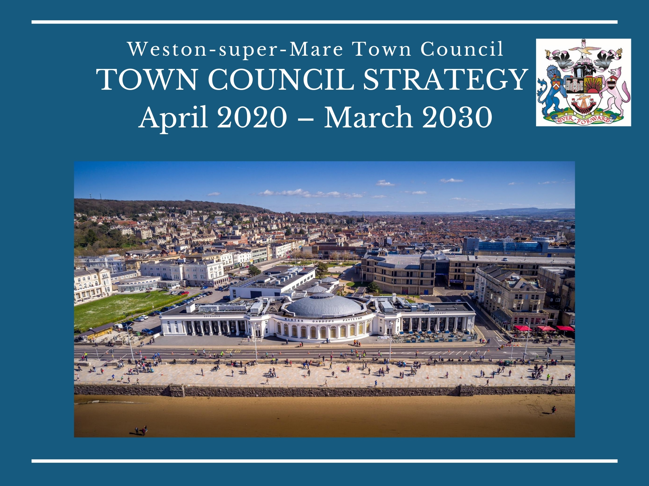
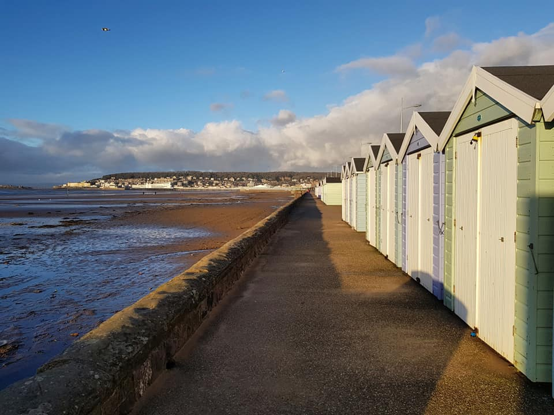
CONTENTS:

Introduction Page 4
Weston Town council Page 6
Core Values page 7
Our ambitions page 9
Councilors PAGE 21

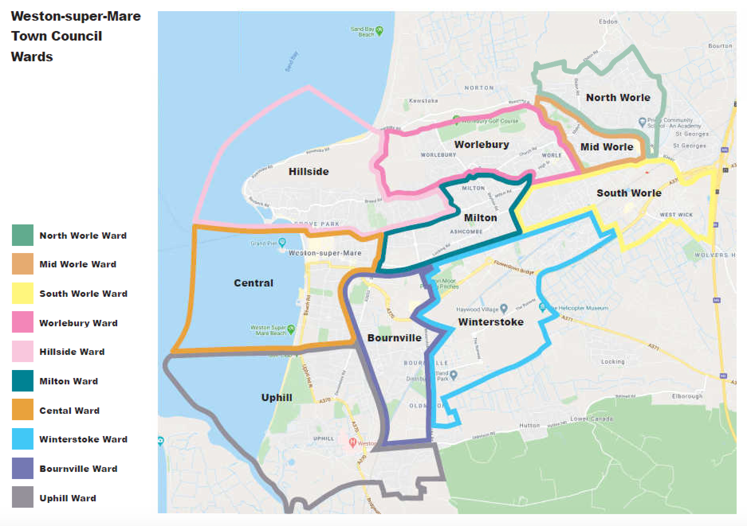
We believe it is important to engage with our local communities. We will continue to listen to ensure that the people of our community are at the forefront of how we shape the outcomes we strive to achieve. The Town Council uses a range of channels for communication to connect with people, including social media alongside the more traditional methods.
We will continue to develop community engagement to make sure even the harder to reach community demographics get their voice heard. We are strongly influenced by what local people have to say about Weston. We are keen to maintain an open dialogue and will listen and respond to suggestions and concerns which are brought to our attention.
This Strategy builds upon and expands that initial work. It provides a comprehensive framework to guide future activities and help us ensure we realise our ambitions for the town. It is a ‘living document’ and will be developed and referred to as we move forward with our plans.
The Town Council understands that not everything will be possible in a shorter time frame and there are many factors outside our control. However, by being clear in our intentions and direct in our efforts, we should ensure we will be more effective in influencing key decisions which affect all aspects of the town and in taking direct action where appropriate to maintain or improve services.

Weston Town Council is an ambitious organisation that wants to do all it can to make our town of Weston-super-Mare a better place to live, work and visit.
We understand that Weston-super-Mare needs a unique, positive identity. Weston Town Council through its cultural, heritage, arts and tourism services is integral to the town’s future identity.
We believe that in these uncertain times with town centre shops closing, challenges to the climate/environment, pockets of social deprivation with differences in health outcomes between wards etc. town councils like ours must play an increasingly important role in helping to maintain and improve local quality of life. Weston-super-Mare is already the third-largest settlement in the West of England with significant further expansion expected.
Like many towns, Weston needs to reinvent itself as a key destination not only for retail but for leisure, events, working, visiting and living.
Through our assets, we are creating a cleaner, greener, safer, more vibrant place to enjoy and where everyone is proud to live and work. Putting a strong emphasis on community benefit, enhancing civic pride, boosting wellbeing, improving mental health and tackling social isolation.
We also want to recognise the town’s unique, rich history as a Victorian seaside town and the traditions of being a Town council.
INTRODUCTION

We will seek a constructive partnership and engagement with a broad range of stakeholders who can help us deliver this plan. That said we will always retain the interests of our town at the core of all of our plans. If this means challenging traditional models and looking for new and innovative solutions for Weston-super-Mare then it is our duty to do so.
The plan is above all a recognition that we must be a Town Council that is relevant and responsible.
This Strategy provides enough detail to prepare annual plans and budgets, while being flexible enough to seize new opportunities as they arise. As a living document it will be developed and evolve as circumstances change around us.
It will undergo annual review, with a full review during 2024.
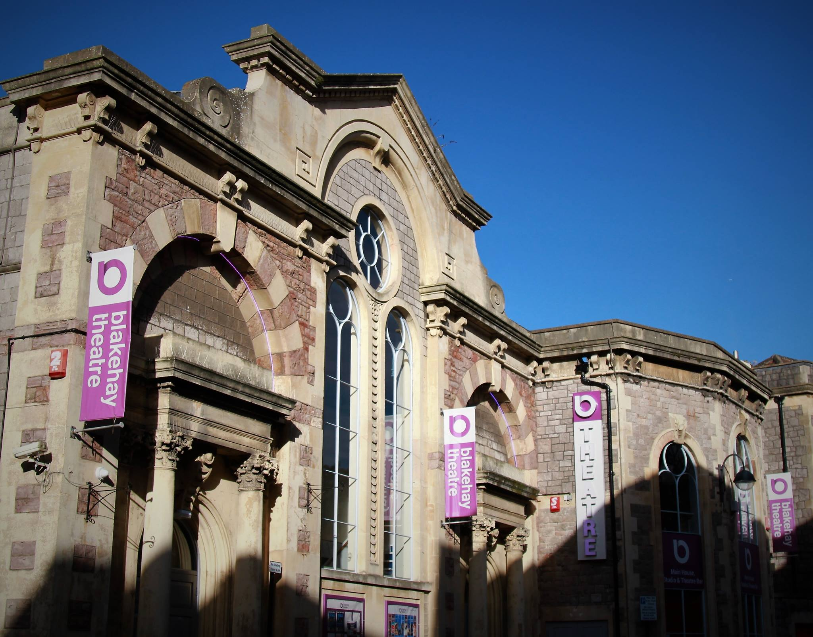

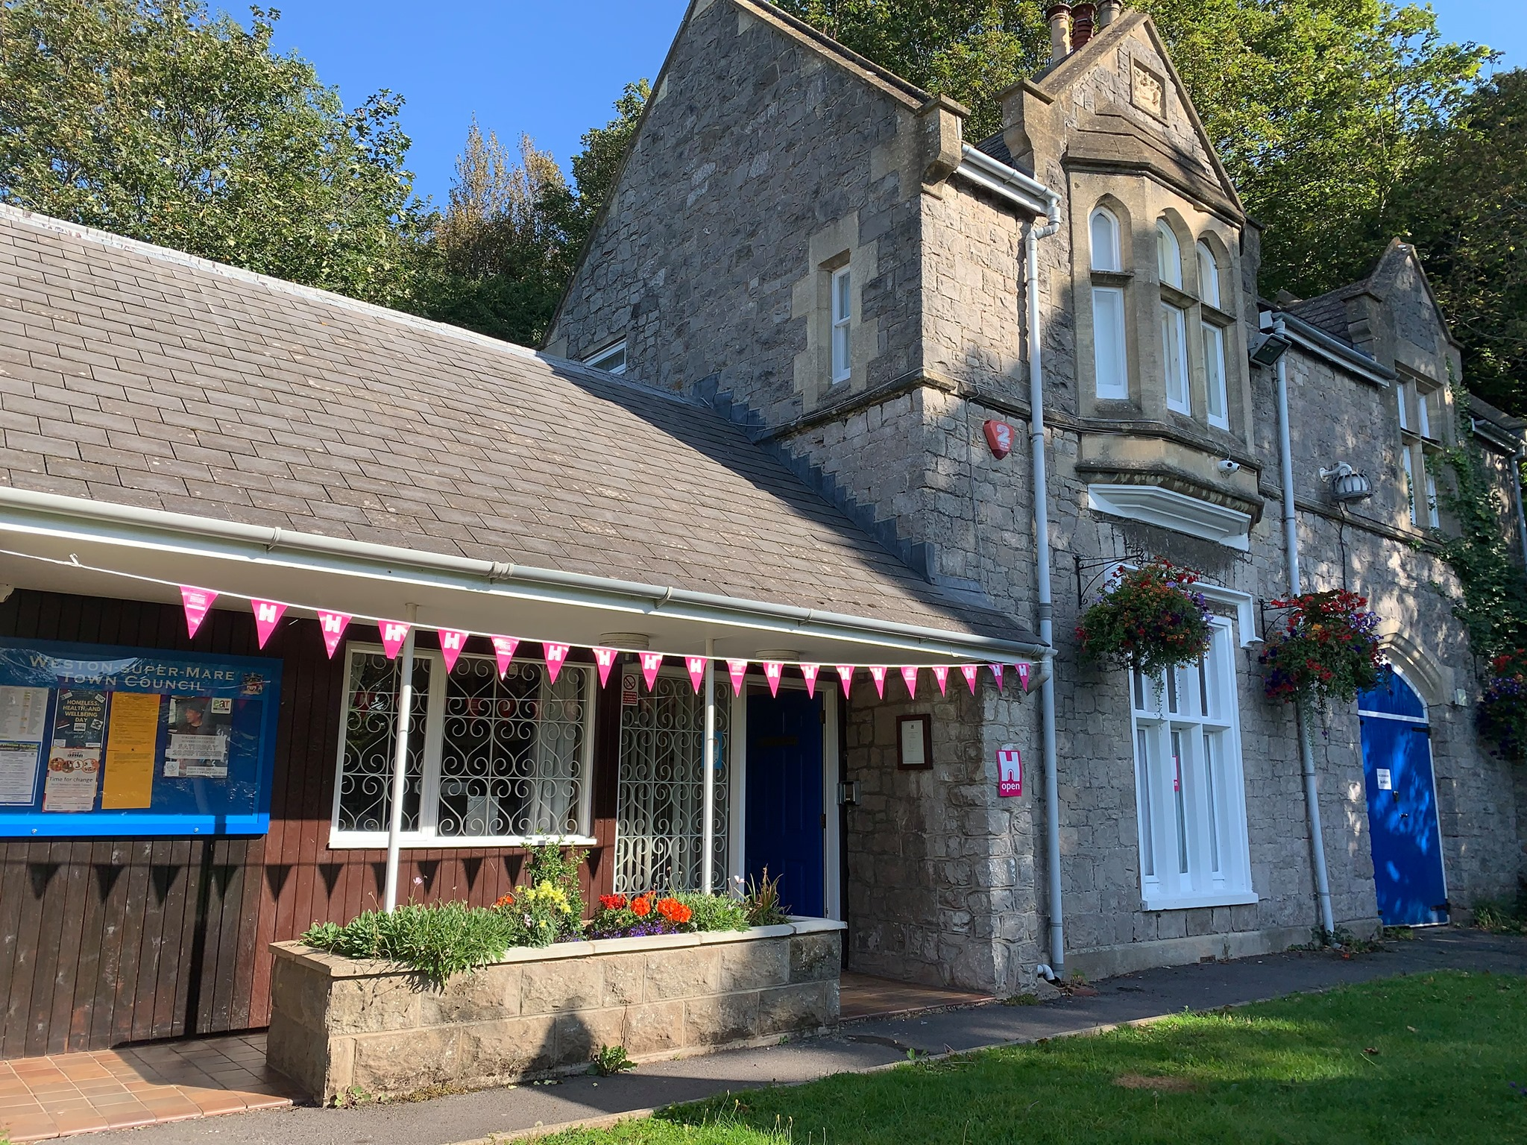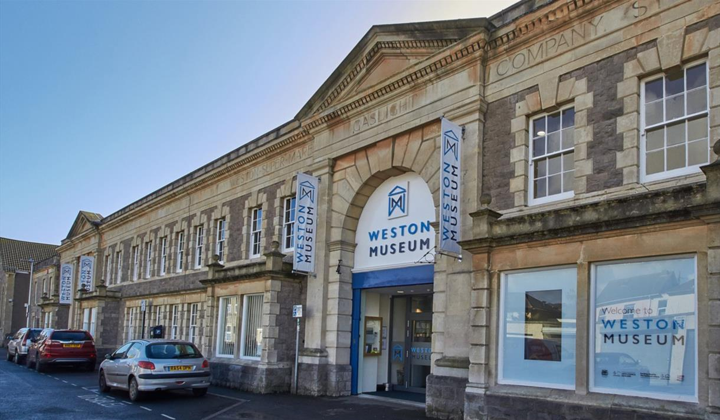
WESTON TOWN COUNCIL
The Council’s main funding comes via its precept - this is a levy made and collected via the council tax charge payable by Weston super Mare residents. Other income is sourced through service provision and external grants.

The 2020 / 2021 expenditure budget is £2,986,522, of which £2,567,270 will be collected via the precept. This equates to £98.37 per year on an average, Band D, household. Within this overall budget, the council has allocated resources to fund projects identified within the strategic plan for this year. Within its financial management, the council will maintain adequate levels of general reserves in line with its financial regulations and will where appropriate maintain a scheme of earmarked reserves which can be used as required to help fund the key strategies and any future major projects identified in this plan.
The Town Council is supported by an officer structure with a core of staff employed within each service area to deliver the Council’s services and policies and ensure decisions are made appropriately. The Council is also committed to using volunteers who work with employed staff to meet objectives and ensure community cohesion.
The structure is headed by a Town Clerk. The officer structure is reviewed annually to ensure that it is able to deliver the broad spectrum of planned activities.

We recognise that the core staff number remains relatively small in number and this will be supplemented as necessary by procuring expertise or services externally in order to ensure there is the capacity to deliver, whilst remaining flexible. The Council is committed to the development of an efficient and innovative operating model in order to achieve its strategic objectives.
The Town Council will adhere to good governance best practice via its adopted and published policies and procedures.
The Town Council will act in the best interests of local people in making representations to:
- North Somerset Council.
- Outside Agencies.
- Central Government.
- Other appropriate private or public sector groups.

The Town Council will operate to the letter and in the spirit of the Equality Act 2010 and in the exercise of all its functions.
The Council has devised ‘five pillars’ or themes that will be referred to later in this document, these ‘pillars’ will form the basis of its strategic aims. This is the Town Council’s statement of what it aims to achieve within the next 5 years 2019 -2024 (short term) whilst also recognising longer-term ambitions (eg. climate change) over 10 years. Whilst not exclusive the projects included have been agreed in principle as areas to support and resource. All projects will be kept under review and may be amended or added to as circumstances change within the duration of the plan.

Human Resources - 2020-2024 HRM Function
The Council will act as a good employer to all Town Council employees, who are entitled to:
• Equal Opportunities.
• A Contract of Employment, Job Description and Person Specification each subject to terms and conditions as determined by current employment legislation.
• Training and development within staff development plans to meet business requirements.
• Recognition in respect of staff pay and grades under the Local Government terms and conditions.
• Issue of Employee Handbooks clearly setting out terms and conditions of employment and maintaining effective grievance and disciplinary procedures.
• Real Living Wage
• Encouragement to join a Trade Union

Town Council staff provide ‘value-added’ in the provision of effective and efficient service provisions. The areas this is achieved and measured are:
1) Reducing absence
2) Good recruitment decisions
3) Raising performance levels
We continue to invest in our workforce via training and development, effective leadership and management and the promotion of consistent ‘Management Standards’.
CORE VALUES

The Council believes it is important to establish a core set of organisational values that determine the way we operate and conduct business.
These three core values are:
- To conduct its business with integrity, impartiality, and transparency in the spirit of the Freedom of Information Act.
- Be a listening and caring Council that treats all views with courtesy and respect.
- To have a positive ‘can do’ attitude in which we believe in the people, businesses and communities of Weston and strive to support them to flourish.

Ambitions involve the Town Council being actively engaged to find solutions which best meet local needs and priorities in respect of significant choices to be made affecting the town’s future.
We will work with the local community and partners to ensure that the Town becomes a more vibrant, better served, more prosperous, cleaner, greener, safer and inclusive place in which to live, work and enjoy life. We will encourage public participation and make known the availability of a public speaking session prior to all Town Council and committee meetings.

The Council will at all times recognise its responsibilities surrounding governance and good finical practice. It will comply with the Code of Conduct and the Nolan Principles in public life and work to an appropriate complaints procedure for use by the public in regards to the Town Council it’s staff and councilors.

Mission –
WORKING WITH THE PEOPLE OF OUR TOWN
CELEBRATING TRADITIONS AND MAKING WESTON SUPER MARE A GREATER PLACE TO LIVE, WORK, VISIT AND ENJOY

Vision -
‘EVER FORWARD’ WE WILL ENSURE OUR TOWN BECOMES A MORE VIBRANT, PROSPEROUS, CLEANER, GREENER, SAFER, AND INCLUSIVE PLACE
FOR EVERYONE TO ENJOY.

Key actions under this priority are based on five “pillars” or themes comprising the following:

Weston View – Measures to promote and better present the Town.
Cleaner and Greener – Measures to improve the local environment.
Healthier and Happier – Measures to promote the health and wellbeing of local residents.

A Bright Future – Measures to support and enhance the local economy.

Heritage, Arts and Culture– Measures to ensure that Weston super Mare thrives as a vibrant place for arts and culture
AMBITION
1. Weston view
To work with local community and partners to ensure that the town of Weston-super-Mare has a positive image, with a vibrant town centre.

Ambition | Council Committee / Department | Timescale | Success would be
1.1 Improve the image of and pride within the town and make it attractive for visitors and businesses. | Communications and Marketing  Tourism and leisure  Civic consultation | 0 to 10 years | Weston-super-Mare having a positive image and identity locally and nationally
1.2 Continue to develop and improve the content of the Town Councils websites and social media. | Communications and Marketing  Policy and finance  Tourism & Leisure | 0 to 1 year | New Town Council website operational by September 2020.  Full compliance of all council websites with WCAG 2.1 regulations.  Improved Website traffic.  All web content kept up to date.
1.3 To encourage local shopping parades to become vibrant well used areas across the town. | Town Council | 0 to 5 years | Proactive work with the partner organisations (i.e BID HAZ) to improve local parades.  Empty shops being used productively and encourage a higher footfall in the town.
1.4 To encourage community initiatives to use the town centre to create events, festivals, fetes, pop-up shops, etc. | Community services | 0 to 5 years | To provide financial assistance for event creation.  More events in the whole town, higher footfall and secondary spend to current retailers
1.5 To oppose additional drug and alcohol rehabilitation centres | Town Council  Planning Committee | 0 to 5 years | Reduction in badly managed drug rehabilitation centres whilst encouraging approved facilities only
1.6 Supporting ‘Somewhere to go’ for homeless people | Town Council | 0 to 5 years | Reduction of homeless people on the streets
1.7 To actively support anti-crime and disorder campaigns within the town, in liaison with the police and North Somerset Council | Town Council  Community services | 0 to 5 years | Provide a safer town environment by a drop in ad-hoc crime
1.8 Implement a Communication Strategy | Communications and Marketing  Policy and finance | 0 to 5 years | Effective internal and external communications.  Provide framework for creating opportunities to raise  awareness of and encourage community participation in  the work of the Town Council.
1.9 Implement a Marketing Strategy | Communications and Marketing  Policy and finance  Tourism & Leisure | 0 to 5 years | Marketing is effective in promoting the work of the council, including town branding, Blakehay Theatre, Waterpark / outdoor spaces, Weston Museum and Tourism.
1.10 Support and increase the range of information available to residents about community based projects, activities and services available to them for the purposes of wellbeing, business and civic pride | Communications and Marketing  Tourism and leisure  HAC  Community services  Civic consultation | 0 to 5 years | Improved use all communication channels (digital, print, and face to face) to provide clear and timely information. Wherever possible, all communications to include 'why' WTC is doing something.
1.11 Provide, fund and support cultural events in the community in collaboration with Place Agency and partners such as Culture Weston | Communications and Marketing  Community Services Blakehay Theatre  Weston Museum  Grounds | 0 to 5 years | To hold a minimum of three successful events, in the old Town Quarry. Well attended with positive feedback, critical acclaim each year.  Successful joint events in the Italian Gardens bringing footfall into the town and elsewhere enabled with Town Council financial support.
1.11.5  Produce a Central Event Listing across departments and organisations in collaboration with the Place Agency. | Visit Weston | 0 to 5 years | To attract large numbers of people and support the art and business economy of the town.
1.12 Provide Christmas lights with Christmas light switch on event | Civic  Community services | On going | A display of Christmas lights in the town, in co-operation with other interested bodies, each year to assist the economic health of the town centre and other appropriate areas.
1.13 The Town Council will support and seek to control the extent and location of CCTV coverage which meets the needs of the town | Town Council  Community services | On going | Provide a safer town environment by a reduction in crime and antisocial behaviour.
1.14 Provision of a Visitor information Centre for tourists and residents in a visible and busy location.  Improve signage around the town for pedestrians. | VIC  Tourism and leisure  Visit Weston | On going | Measured increased numbers of tourists to Weston  Measured usage of VIC by local residents.  Identify and move to a more central location resulting in greater footfall  Greater connectivity on foot  – easier to find key WTC and other facilities – link seafront better to town centre businesses
1.15 To encourage licensing of private landlords owning rental properties (inc HMO’s) | Planning Committee and Town Council | On going | Licensing in place, better quality accommodation within the town
1.16 Encourage people living and working in Weston to participate and to engage in decision making. | Communications and Marketing  Policy and finance | On going | Implemented activities and surveys that improve public participation and engagement, demonstrating proactive community governance
1.17 Internal Communications between all departments, staff and Cllrs | Communications and Marketing  Policy and finance | On going | Improved clear and up to date news and information across all departments. With all departments using the Hub and the weekly Highlight report.
1.18 Provide the Visit Weston (website) to promote destination marketing | VIC  Tourism and leisure | On going | Up to date information on the Visit Weston website and social media.
1.19 Enable provision and maintenance of street furniture | Grounds  Community services | On going | Providing where needed and maintaining street furniture eg bins, bus shelters, benches etc
1.20 To work with Weston Town Centre Partnership via Service level agreement | Policy and finance | On going | Work within the criteria of the SLA in the promotion of Weston-super-Mare Town centre including the up-keep of the town clock
1.21 Fund Uphill church lighting electricity costs | Policy and finance | On going | Continued floodlighting of iconic landmark in Uphill
1.22 The Town Council will maintain and provide new community notice boards in key locations throughout the town as a means for publicising Town Council and community facilities and activities. | Communications and Marketing  Community services | On going | Locations with noticeboards reviewed every six months.  Noticeboards kept up to date.  Noticeboards clean and in good condition
1.23 The Town Council will fully consider local opinion when presenting recommendations to North Somerset Council regarding planning applications and relevant consultations. | Town Council  Planning Committee | On going | To act as proactive consultee to North Somerset Council for all planning applications and developments in the town
- Cleaner and Greener
To work with local community and partners to ensure that the town and its wards become a cleaner and greener place to live and work protecting and enhancing the environment.
Ambition | Council Committee / Department | Timescale | Success would be
2.1 The Town Council aims to be carbon neutral by 2030 | Town Council  Climate emergency working group | 0 to 10 Years | Understanding our current carbon footprint at 2020.  Establish and follow a programmed ‘road map’ of key performance areas to achieve carbon neutral status 2030.  Areas covered: Buildings, operations, activities, vehicles (Both Town Council and Staff)
2.2 Reduce waste and consider disposal options to include composting, recycling and reusing across all Town Council services | Climate emergency working group | 0 to 2 years | Demonstrable reduction in all waste products to reduce carbon footprint
2.3 Supporting ‘Cleaner coastlines’ for Weston’s plastic free ambitions | Communications and Marketing  Climate emergency working group | 0 to 2 years | Actively support with publicity of beach cleans and other events.  Eliminate single use plastic in all Town Council facilities.
2.4 To promote biodiversity.  To create a ‘rewilding’ programme in cohesion with North Somerset Council in appropriate areas | Grounds  Climate emergency working group | 0 to 5 years | Established ‘rewilded’ areas of natural beauty in place.
2.5 To maintain current and increase current tree stocks to offset carbon.  In addition to look for more opportunities to plant trees in our area. | Grounds  Community services  Climate emergency working group  Planning Committee | 0 to 5 years | To maintain a robust tree management plan for all Council owned land, to include that when a tree is felled, a replacement is planted.  More established trees on Council land.
2.6 To provide community support to ensure the up-keep of community areas i.e. paths, cycleway and verges in conjunction with North Somerset council.  Identifying needs through ward members and working with community groups | Community services | 0 to 5 years | Clean open spaces and safe environments for community use, with feedback from general public.  Improved cleanliness of public spaces above SNC standards
2.7 To continually review the effect of any proposed expansion plans at Bristol airport | Town Council | 0 to 5 years | Reduced carbon footprint of Bristol airport.
2.8 To provide Town Council Staff / members opportunity to engage in ‘ride to work’ and bike purchase schemes | Town Council  Climate emergency working group | 0 to 5 years | Reduction in car use and carbon footprint.  Improve health and wellbeing.
2.9 Provision of Allotments to meet local demand and enable residents to grow their own food. | Grounds  Community services | 0 to 10 years | Quarterly meetings in the calendar; progress reports discussed at quarterly meetings; and works completed to the satisfaction of the allotment holders.  Review of current allotment sites and provision of new facilities if required by demand.
2.10 To encourage North Somerset Council to include cycle paths on new development sites | Town Council  Planning Committee | 0 to 10 years | Weston becomes a safer town encouraging cyclists, with more people choosing a bike as their mode of transport and to reduce area carbon footprint
2.11 To improve the provision of Dog waste bins and service to the community | Grounds  Community services | 0 to 2 year | Make clear which are Town Council bins and which are North Somerset.  Continue to empty bins in a timely fashion.  Create a map of the locations of the bins for the Town Council website.  Review of the location of the dog waste bins and place or remove them where needed.
2.12 To reduce energy and fuel consumption across all council activities and services.  To change to 100% renewable energy (i.e. solar panels, electric vans and energy providers) | Climate emergency working group | 0 to 10 years | Demonstrable reduction of energy use.  Use of Green energy providers  Change to green vehicles for operational teams, including use of electric bikes.
2.13 The Town Council will continue to maintain and improve the facilities at Milton Road Cemetery as a heritage site, a wildlife and environmental amenity, and as a working cemetery for burials and the interment of cremated remains | Grounds  Community services | 0 to 10 years | Continue to maintain high standards in the cemetery, working to deliver climate emergency criteria.  Increased public use of the cemetery.  Demonstrable improvements to support biodiversity, rewilding, reduce waste generation (composting)
2.14 To give preference wherever possible to the procurement of goods and services from locally based suppliers subject to best value principles | Finance  Policy and finance | On going | Reduced carbon footprint from travel / supply distance consistent with best value and use of public funds.
2.15 Weston in Bloom and flower bed provision.  Provide floral displays for spring /  to decorate centres | Grounds  Community services | On going | Continue to enter ‘In Bloom’ awards and gain positive feedback from local residents.  Consider alternative/sustainable planting schemes where appropriate and reduce waste.
2.16 Enable provision of parks and play areas as  community facility | Climate emergency working group  Tourism and leisure | On going | Continue to maintain high standards in the parks and play area locations. Working efficiently to deliver every day and reactive work meeting climate emergency criteria.  To encourage increased public use of parks, biodiversity, rewilding, reduce waste generation (composting)
2.17 To support and work with Weston in Bloom volunteers and partner organisations on floral displays | Grounds  Weston in Bloom working party |  | Provision of beautiful and award winning flower displays around Weston and Worle

3. Healthier and Happier
To work with local community and partners to ensure that the town of Weston-super-Mare and its wards prioritise its residents’ health and wellbeing.
Ambition | Council Committee / Department | Timescale | Success would be
3.1 Develop and maintain Community Support and Resilience working with community volunteer groups to enhance the town  Identify opportunities for greater use of community groups to operate services and facilities | Town Council  E&G  Community Resilience Team | 1-5 years  Ongoing | Community Support a permanent activity following Covid 19 pandemic, fulfilling community needs through volunteers  An agreed Community Engagement/ Resilience Outcomes Framework to identify priortise and Community Resilience Team and voluntary group efforts.
3.2 To work with community partners (NSC, Police, street wardens) to create a safe environment for local residents | Policy and finance  Community Services | 0 to 5 years | Work closely with the police, resident groups, the business community and other bodies resulting in improved community safety and reduced crime throughout the town (Crime and Disorder Act s.17)
3.3 To find sustainable solutions to secure the future of some key community assets such as - Drop in cafes, dementia activities, SEN sessions, volunteering, Mayors charity ETC | Museum  Blakehay Theatre  Civic  Community Resilience Team to this column | 0 to 10 years | Continue to create events via our assets that are inclusive of a diverse range of our community and inclusive for demographics that can be excluded.  To reduce loneliness in the town by giving access for community groups to gather in our venues.  Liaison with specialist groups.  Target old-age loneliness and explore opportunities to bring old and young together.  Help to promote diversity and equality.
3.4 The Town Council will maintain, support and encourage a Youth Council to enable and encourage young people to take part in the democratic governance of the town | Youth Council | On going | A vibrant youth council with a good membership.  Good communications between the youth council and the Town Council.
3.5 The Town Council will work in partnership with the YMCA and others to support the provision of necessary youth services in the town | Community services | On going | Having a YMCA that benefits young people and gives them support and somewhere to go that suits their needs supported by the Town Council via an SLA.
3.6 Follow and regularly review an appropriate Health and Safety Policy that complies with the relevant legislation for the Town Council | Health and safety team  Policy and finance | On going | To provide a safe, secure working environment for all staff, councillors, volunteers and service users.
3.7 To support local voluntary organisations where deemed appropriate via the grant system | Community services | On going | Grant application forms are continually available throughout the year with decisions normally made at the appropriate Community Services Committee meetings.  Applications from organisations requiring financial assistance over £1,000 considered at the Policy and Finance Committee.  Increased public awareness of the availability of grants  Continuing to aid VANS and CAB with financial support
3.8 Provide provision of Allotments as  community facilities | Grounds  Allotments committee | On going | Provide practical support in our partnership with the Allotments Club.  Completing agreed works in a timely fashion.  Quarterly meetings in the calendar with the Allotments Club.  To provide additional allotments where needed.  To encourage health and wellbeing in the community
3.9 Provision of parks and play areas as a community facility  To maintain and develop the Water Park to meet the needs of both local residents and visitors.  Celebrate and enhance Grove Park as showpiece town centre park  ADD Explore taking on Weston and Worle’s main parks including Ellenborough, Clarence, Ashcombe and Castle Batch parks | Grounds | On going | Existing play areas maintained to a high standard.  Provide, in consultation with local communities, new or refurbished play areas and associated equipment in each  ward.  Healthier and Happier communities. Safe, clean environments for families.  Well designed and good play equipment.  Encourage opportunities to increase participation in personal health and fitness activities  Provide support for social inclusion initiatives for people with additional needs in more locations around Weston and Worle.
3.10 Provision of public toilets to meet need.  Review and improve provision of public toilets to meet need  Develop Community Toilet Scheme | Grounds  Community services | On going | Public toilets provided and safe and clean for the community to use.  More Toilets open to the public  Fewer incidents of vandalism and closure
3.11 The Town Council will work to the letter and in the spirit of equality and health and safety legislation and continue to develop our commitments towards ‘Disability Confident’. | HR | On going | Equality and health and safety legislation compliant.
3.12 The Town Council will strive to ensure good year-on-year practices in health and safety; equality and diversity; wellbeing; inclusivity and safeguarding initiatives in all our departments | HR and all departments | On going | No staff members involved in accidents, time off due to stress, bullying, and inclusion in all areas of employment.
4. A Bright Future
To work with its own resources and with the local community and partners to ensure that the town of Weston-super-Mare and its wards has a bright long term future for its local economy

Ambition | Council Committee / Department | Timescale | Success would be
4.1 To work with business in the town, in the economic development of Weston-super-Mare.  Work with business in the town in the economic development of WsM ADD through the Place Agency to support business and the town economy. | Town Council | Ongoing | A vibrant business community with growth of employment and fewer retail and office vacancies.  Town Council a central partner in the Place Agency, with a place on the Board to ensure strong influence  Agency to bring inward investment
4.2 To provide a voice for the local business community to North Somerset Council Place Agency. | Town Council | Ongoing | Evidence that local business opinion and voice is being heard and considered by North Somerset Council in its policy ambitions
4.3 To support any improvement to the visual impact of the access routes into town | Town Council  Planning committee | 0 to 5 years | To be a consultee to North Somerset Council strategic planning
4.4 Consult with local people regarding the provision of Town Council services and facilities | All | 0 to 5 years | Production of community engagement policy and annual programme of consultation to enable an open forum for residents to voice any concerns or raise any subject affecting Weston-super-Mare.  Community organisations to participate in events held at Town council sites  Use of all appropriate means including an annual report, website, social media and noticeboards to inform residents of the Town Council's activities.
4.5 The Town Council will keep all Town Council services under review to ensure economy, efficiency and effectiveness. | Town Council | 0 to 5 years | Annual reviews of services and adjusting its precept according to the town’s needs.  Comparing its services with similar organisations
4.6 To support the sustained growth of tourism business to Weston-super-Mare. | Tourism and leisure | 0 to 10 years | Greater footfall into Weston-super-Mare.  Increase number of business partners to support the Visit Weston brand
4.7 Deliver services to the highest quality in terms of efficiency, effectiveness and value for money.  Adopt a Social Value Policy. Assess on a consistent basis the Social Value of WTC services and facilities. | Policy and Finance, Expenditure and Governance Working Party | 0 to 10 years | Annual review of strategy.  Regular and robust internal and external audit reports and positive satisfaction surveys.  The social value of services facilities and contracts consistently assessed against financial costs, using recognised and respected criteria
4.8 Fit for purpose Standing Orders and Financial Regulations | Town Council  Policy & Finance committee | Annually | Regularly reviewed and robust standing orders and financial regulations
4.9 Ensure its staffing structure is fit to meet business needs | Personnel Committee |  | Annual reviews of staffing structure completed and actioned.
4.10 Seek, subject to agreed budgets, to maximize income derived from all sources | Policy and Finance Committee | Annually | Income targets are realistic and achieved in any financial year
4.11 To comply with legislation to ensure healthy financial records | Town Council | Annually | Accounts prepared to comply with the Local Audit and Accountability Act 2014, The Accounts and Audit Regulations 2015 and follow advice from the external auditor
4.12 Ensure adequate level of insurance provision for Town Council operations and assets | Town Council  Policy and finance | Annually | Regularly review public liability and indemnity insurance values
4.13 The Town Council will only put in place facilities and premises which it can afford to maintain. | Town Council  Policy and finance | Annually | An adequate percentage of revenue funding is placed in the budget each year for planned maintenance of Town Council premises and facilities
4.14 To support the local economy with the use locally based contractors and partners.  Social Value of contracts (eg local employment) included in review of procurement policies | All | On going | Use of mainly locally based contractors and partners for outsourced services and works where practical.  Social value of all contracts measured against economic costs using consistent criteria
4.15  Identify opportunities from new technology for more efficient working for staff and councillors. | E&G  Personnel Committee | 0 to 5 years | Enable part time home working for more employees on a permanent basis  Reduction in premises required through homeworking and desk sharing.  reduce unnecessary travel
4.15.5 Enable small committees and working parties meeting on a remote basis permanently  Consider more remote meetings in winter months | Town Council  All committees  Administration |  | Increase meeting attendance.  Equalities – where remote mtgs easier for people with children or disabilities  Climate Change – reduced member and officer travel
4.16 Support development of broadband connection by Fibre across the whole of Weston super Mare. | Town Council | 2021-23 and ongoing | Ultra high speed 5G connectivity for all 45-50,000 homes and business premises in the town, enhancing business opportunities and jobs
4.17 Support development of Autonomous Vehicles on the sea front and beyond | Town Council  Tourism and Leisure Cttee  Visit Weston | 0 – 10 years | Weston recognised as a tech leader  Autonomous vehicles running a regular service on the sea front or elsewhere by say 2025
4.18 promote Fairtrade business practices in the town | Town Council | 0-5 years | Weston-super-Mare achieves Fairtrade Town certification from the Fairtrade Foundation

5. Heritage, Arts and Culture
To work with local community and partners to ensure that the town of Weston-super-Mare has growing opportunity for Culture, Heritage and the Arts.

Ambition | Council Committee / Department | Timescale | Success would be
5.1 The Town Council will continue to support and encourage the provision of facilities for arts and culture in the town | HAC | 0 to 5 years | Increased arts and culture presence in Weston-super-Mare including music, visual arts, dance and performance venues.
5.2 The Blakehay Theatre to become a zeitgeist for cultural development and dramatic arts in the town. Providing modern facilities for the performing and visual arts and community activities.  The Town Council will develop and further promote the management and marketing of the Blakehay Theatre so that it becomes a recognised venue for regular drama, comedy, musical and other productions of performing arts. | HAC | 0 to 5 years | Increased use of the theatres facilities with a growing number of shows and events  To create Theatre for the whole community, bringing national popular shows and treading subject matters onto the stage.  To promote a creative hub for artists and performers in the local area and a cultural home for fans of the arts.  To create a uniquely diverse program of locally produced and touring work.  Creation of an inclusive creative community.
5.3 Weston Museum (as a result of heritage lottery funding) will be maintained as a diverse community resource whilst maintaining its Museum focus and access to heritage and learning.  The Museum to be the best tourist attraction in the Town centre, whilst developing itself as an arts and cultural destination for the benefit of both the local community and visitors to the town. | HAC | 0 to 5 years  0 to 10 years | The management and marketing of the Weston Museum further developed so that it becomes a regionally recognised venue for heritage arts and culture.  Increased use of the hire space with a growing number of events and education sessions, with adequate resources to support.  Creation of a uniquely diverse program of events.  Current volunteer programme extended and increase in number of active volunteers.  To redevelop Clara’s cottage, securing grant funding to support this. (Phase 2)  To redevelop remaining spaces within the Museum (Phase 3)
5.4 Promote and celebrate sites of local historical interest. | HAC | 0 to 5 years  5 to 10 years | Completed current programme of personal Blue Plaques with link to the website and audio tour.  Following the completion of personal Blue Plaques to effect a Blue Plaque scheme for buildings within Weston-super-Mare
5.5 To host and organise a Weston ‘community focus’ festival | HACC | 0 to 5 years | Popular event measured by high footfall and from residents and from outside the town.
5.6 To strengthen social cohesion through running and supporting activities events, festivals, youth initiatives and clubs alongside managing Town Council facilities and shared spaces for the community | Community services | 0 to 5 years | Increased community event programme within Weston-super-Mare and Town Centre (both directly put on by the Town Council or supported by the Town Council.)
5.7 To maintain the civic traditions of the town’s Mayoralty. | Civic consultation  Town Council | On going | Election of a Mayor annually and robust program of engagements within the town.  Recognition of the Mayor as the town's ceremonial head. The Town Mayor chairs all meetings of the Town Council.
5.8 To maintain and assist community organisations with the town twinning with Hildesheim.  Review twinning arrangements | Civic consultation  Town Council  Youth Council | On going | Active communication and promotion of twinning links  Identify opportunities for new or improved twinning links  Use of volunteers
5.9 Take over and operate Town Quarry in conjunction with local arts community | HAC Cttee  Grounds | 0 – 10 years | Secured long term future for Quarry as an arts heritage and culture venue
5.10 Explore restoration of historic Grove House to its original size and footprint | HAC Cttee | 0 - 10 years | Grove House restored as close as possible to its original appearance and in beneficial and economic use
5.11 Work with North Somerset Council to safeguard and interpret Worlebury Hillfort | HAC Cttee  Museum  Grounds | 0 – 10 years | Improved and interpreted Hillfort a visible and accessible visitor and local attraction
5.12 Support North Somerset Council’s Heritage Action Zone | HAC Cttee | 0 – 5 years | Regeneration of historic buildings and streetscapes in Weston

FOX, Peter | CONSERVATIVE | UPHILL
GIBBONS, Catherine | LABOUR | BOURNVILLE
HITCHINS, David | CONSERVATIVE | SOUTH WORLE
HOLLOWAY, Jan | CONSERVATIVE | NORTH WORLE
MCALEER, Peter | LABOUR | MILTON
PAYNE, Robert  PEPPERALL, Marcia | LIBERAL DEMOCRAT  CONSERVATIVE | CENTRAL  NORTH WORLE
PEAK, Alan | LABOUR | BOURNVILLE
PILGRIM, Lisa | CONSERVATIVE | WORLEBURY
PORTER, Ian  RUSSE, Sonia  SAYCE, Ella  TAYLOR, Timothy | CONSERVATIVE  CONSERVATIVE  LIBERAL DEMOCRAT  LABOUR | WORLEBURY  MID WORLE  CENTRAL  MILTON
THORNTON, Helen | LABOUR | UPHILL
TUCKER, Richard | LABOUR | MILTON
WILLIS, ROSSLYN | CONSERVATIVE | WORLEBURY

COUNCILLOR | PARTY | WARD
AGASSIZ, Dorothy | LABOUR | MILTON
APLIN, Marc | CONSERVATIVE | NORTH WORLE
ARMSTRONG, Ray | LIBERAL DEMOCRAT | HILLSIDE
BAILEY, Roger | CONSERVATIVE | UPHILL
BELL, Mike | LIBERAL DEMOCRAT | CENTRAL
BUTE, Gillian | CONSERVATIVE | MID WORLE
CANNIFORD, Mark | LIBERAL DEMOCRAT | HILLSIDE
CARPENTER, Gillian | LABOUR | SOUTH WORLE
CLAYTON, James | LABOUR | BOURNVILLE
CODLING, Sarah | CONSERVATIVE | WINTERSTOKE
CREW, Peter | CONSERVATIVE | SOUTH WORLE
CROCKFORD-HAWLEY, John | LIBERAL DEMOCRAT | HILLSIDE
CRONNELLY, Ciaran | LABOUR | WINTERSTOKE
DASH, David | LABOUR | SOUTH WORLE

Weston-super-Mare Town Councilors 2019 - 2023

Weston-super-Mare Town Council
Grove House
Grove Park
Weston-super-Mare
BS23 2QJ

Produced by Becky Walsh and Sarah Pearse
Approved by Town Clerk Malcolm Nicholson on behalf of Weston-super-Mare Town Council

