Park at Castle Batch for people with special educational needs
Weston-super-Mare Town Council would like the help of local children and young people in creating a park at Castle Batch for people with special educational needs.
We want to know what you would like to see in the new play area at Castle Batch Park.

- How old are you?

_________________________
- How do you travel to the park? Please tick all that apply:

Car
Taxi
Bike 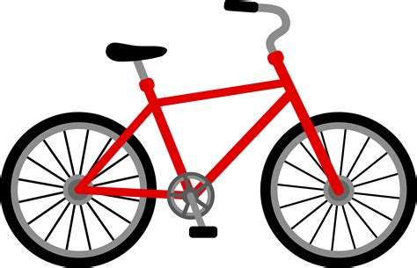
Bus
Walk 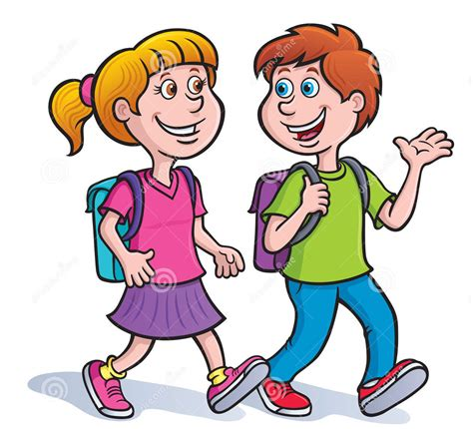

Other ____________________________________
- What activities do you like to do when you go to the park (please choose 3)?
Swinging 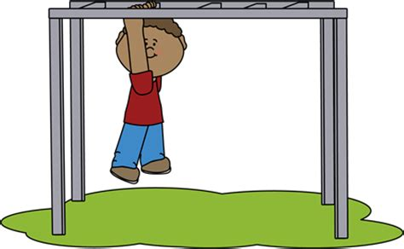
Spinning 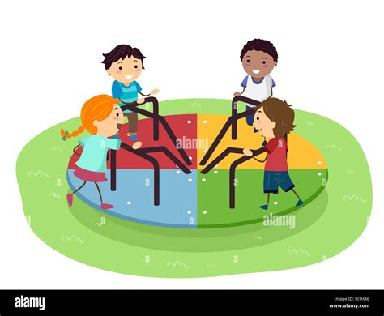
Sliding
Climbing
Balancing
Bouncing

- If you could add 2 pieces of play equipment to the park what would you choose? You can only tick 2!
Climbing frame 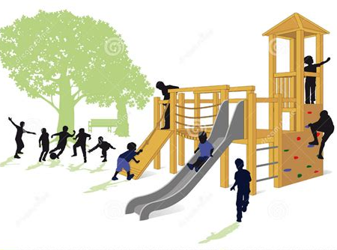
Balance equipment 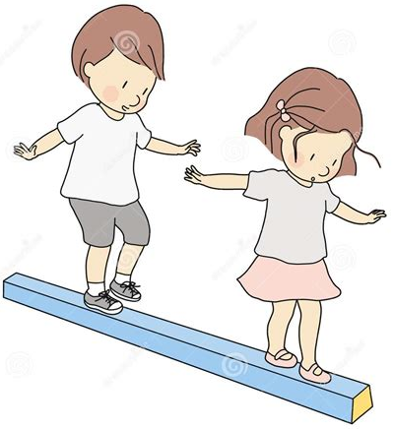
Climbing nets 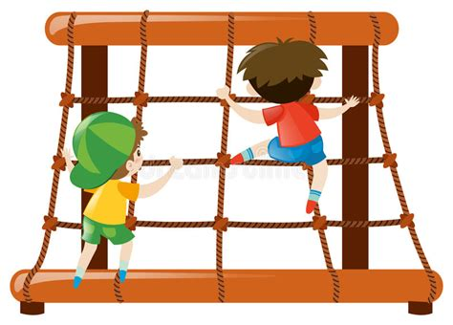
Seesaw
Swings 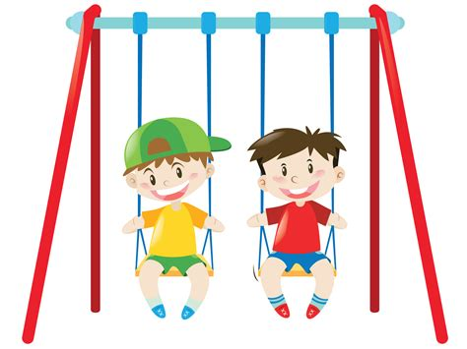
Roundabout
Slide
- Are there any other comments you would like to add?
(write or draw)

