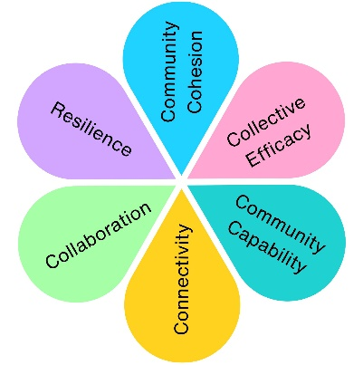
Clara’s Cottage Redevelopment
Following the successful refurbishment of Weston Museum in 2017, Clara's Cottage remained one of the few undeveloped areas of the museum. Weston-super-Mare Town Council undertook a public engagement exercise between August 2019 and March 2020 to understand what visitors wanted from the next phase of the museum's redevelopment.
Alongside an online survey, visitors were able to speak to officers through an information stand within the museum, helping to shape proposals for the future of Clara's Cottage.
The feedback directly informed a National Lottery Heritage Fund project enquiry, submitted in partnership with South West Heritage Trust in March 2020. Unfortunately, the application was returned without assessment following the suspension of funding programmes during the COVID-19 pandemic.
How We Engaged
Online Public Survey
Museum information stand
Conversations with museum visitors

Community response
381 survey responses received
The consultation demonstrated strong public support for completing the museum redevelopment.
Visitors told us they valued:
- Local history
- Victorian heritage
- Permanent exhibitions
- Better use of museum collections
- Clara's Cottage as an important part of the visitor experience
The engagement also highlighted opportunities to improve accessibility, interpretation and learning opportunities for future generations.
66% said history was the most important reason for visiting the museum
69% identified Victorian history as their greatest area of interest
45% wanted more permanent exhibition space
59 specifically selected Clara's Cottage as a main attraction
129 said they visit primarily to see the museum exhibits
107 cited an interest in local history as a reason for visiting

How community feedback shaped the project
The consultation directly informed proposals to:
- Restore Clara's Cottage using authentic period interpretation
- Reveal historic features of the building
- Improve accessibility for disabled visitors
- Create new learning opportunities for schools
- Involve volunteers and young people in historical research
- Increase opportunities for community participation
- Better integrate Clara's Cottage into the wider museum experience
Legacy
Although the project was unable to proceed because of the COVID-19 pandemic, the engagement established a clear evidence base for future investment in Weston Museum and demonstrated the value of involving residents in shaping the future of their local heritage. The consultation also strengthened partnership working between Weston-super-Mare Town Council and South West Heritage Trust and created a detailed, community-led vision for Clara's Cottage that could support future funding opportunities.

Impact Assessment
 | Theme | Evidenced? | Project Contribution
 | Physical Health
 | Mental Wellbeing | ✓ | Opportunities created for people to connect with local heritage and culture.
 | Social Inclusion | ✓ | Community members helped shape the future of a shared cultural space.
 | Community Connection | ✓ | Strengthened partnerships between the museum, heritage organisations and the local community.
 | Environmental Benefit
 | Economic Benefit | ✓ | Community feedback informed a heritage funding application for future investment.
 | Skills & Learning | ✓ | New opportunities identified for volunteering, learning and heritage interpretation.
 | Accessibility & Equality | ✓ | Community feedback informed proposals to improve access and inclusion within the museum.
 | Community Pride | ✓ | Helped shape the future of a valued local heritage asset.

