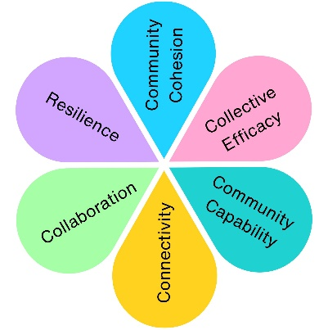
Know Your Place - Sharing Local Heritage Through Community Participation
Know Your Place was a National Lottery Heritage Fund project that encouraged local people to research, record and share the heritage of Weston-super-Mare and North Somerset. Working with volunteers, community groups and young people, the project created new opportunities for residents to contribute local knowledge, photographs and stories to a publicly accessible heritage resource.
At a Glance
12
Volunteers actively involved
990.5 Volunteer Hours Contributed
700
Heritage Contributions uploaded to KYP

What Happened?
Volunteers Bringing Heritage to Life
Residents were trained and supported to:

✔ Research local history
✔ Digitise photographs
✔ Upload heritage records
✔ Create educational resources
✔ Support community outreach activities
✔ Share local knowledge and stories

The project enabled local people to become active contributors rather than passive audiences.
Young Ambassadors
Through Weston Museum's Rusty Club, young people explored local heritage and became advocates for the project.
Activities included:





Exploring historic maps

Researching local places
Supporting archaeology events

Promoting the Project to Visitors

Several young people acted as Young Ambassadors at public events.

Reaching the Community
The project engaged people through:
Weston Museum
NS Libraries
Festival of Archaeology
Local History Societies
Community Groups
NS Heritage Forum

Adapting During COVID-19
When face-to-face engagement became impossible:
- Events moved online
- New Facebook and Twitter channels were launched
- Digital resources were developed
- Volunteer activity continued remotely
The project successfully maintained participation during lockdown and significantly increased its digital reach.





X2 Website Traffic
433 Twitter Followers
446,500 Twitter Impressions
512 Facebook Members
What Changed?

The project helped create:

✔ A growing digital heritage resource
✔ New volunteer skills and confidence
✔ Stronger links between heritage organisations
✔ Opportunities for young people to engage with local history
✔ Increased public access to local heritage information
✔ Educational resources for schools and families

The Difference Community Participation Made
Know Your Place demonstrated the value of community participation in preserving local heritage. Through volunteering, research, outreach and digital contributions, local people helped ensure that the stories, places and history of Weston-super-Mare and North Somerset could be shared with future generations.
Impact Assessment
 | Theme | Evidenced? | Project Contribution
 | Physical Health
 | Mental Wellbeing | ✓ | Volunteering and participation created opportunities to build confidence, purpose and wellbeing.
 | Social Inclusion | ✓ | Residents of all ages contributed their knowledge, stories and experiences to a shared heritage resource.
 | Community Connection | ✓ | Strengthened relationships between volunteers, community groups, schools and heritage organisations.
 | Environmental Benefit
 | Economic Benefit | ✓ | National Lottery Heritage Fund investment supported volunteering, skills development and local heritage initiatives.
 | Skills & Learning | ✓ | Volunteers developed research, digital and heritage skills while creating educational resources for future generations.
 | Accessibility & Equality | ✓ | Digital heritage resources increased public access to local history and enabled wider community participation.
 | Community Pride | ✓ | Celebrated and preserved Weston-super-Mare's heritage through community-led research and storytelling.

