2020 Community Outcome Round-Up
Community Engagement Sessions
April 2019 – September 2020: Know Your Place
Supported by National Lottery Heritage Fund funding, the project encouraged local people to research, record and share Weston-super-Mare's history through volunteering, digital mapping and community outreach. Despite the challenges of the COVID-19 pandemic, the project successfully adapted to online delivery, creating a lasting digital heritage resource while developing volunteer skills and strengthening partnerships across the heritage sector.

August 2019 – March 2022: Clara’s Cottage Redevelopment
In order to understand the community's aspirations for the second phase of Weston Museum's refurbishment, a light-touch engagement exercise was undertaken to help shape future plans for Clara's Cottage. The feedback directly informed a National Lottery Heritage Fund application submitted in March 2020. Unfortunately, following the COVID-19 pandemic, the funding programme was suspended and the application was returned without assessment. As priorities shifted towards recovery, the redevelopment was placed on hold, but the community feedback remains a valuable evidence base that can support future investment in the site.



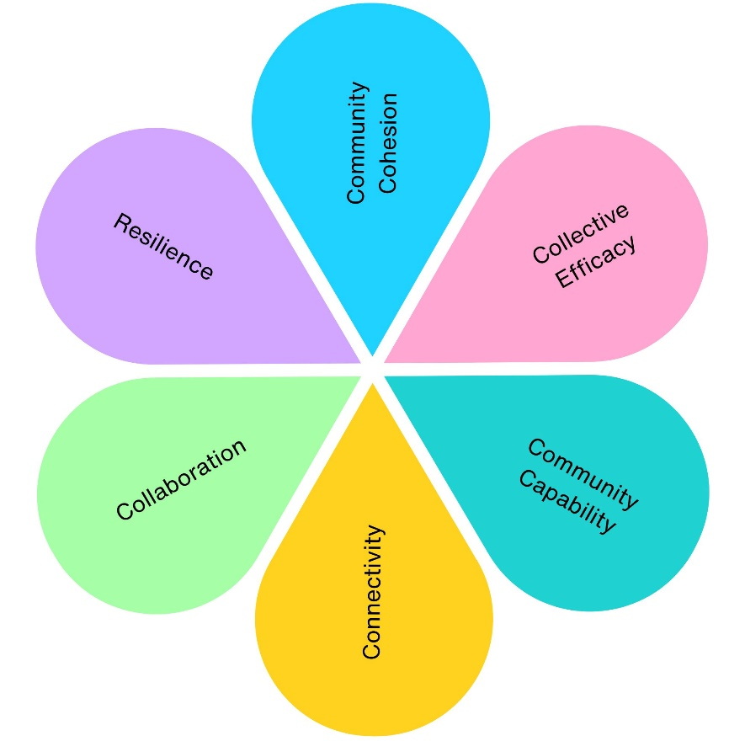
1
1
2
1
2
2

2020 Community Engagement Impact
Across 2 community engagement projects, we have contributed to:
- 2 projects supporting mental wellbeing (Know Your Place, Clara's Cottage Redevelopment)
- 2 projects improving social inclusion (Know Your Place, Clara's Cottage Redevelopment)
- 2 projects strengthening community connections (Know Your Place, Clara's Cottage Redevelopment)
- 2 projects delivering economic benefits (Know Your Place, Clara's Cottage Redevelopment)
- 2 projects supporting skills and learning (Know Your Place, Clara's Cottage Redevelopment)
- 2 projects increasing accessibility and equality (Know Your Place, Clara's Cottage Redevelopment)
- 2 projects promoting community pride and participation (Know Your Place, Clara's Cottage Redevelopment)
- 393 residents and visitors directly engaged (381 Clara's Cottage survey responses and 12 active Know Your Place volunteers)
- 700 local heritage records and stories contributed to a publicly accessible digital heritage resource.
- 990.5 volunteer hours contributed to researching, recording and sharing Weston-super-Mare's heritage.
- 1 major heritage funding application developed using community feedback to support the future redevelopment of Clara's Cottage.
- 2 major heritage partnerships strengthened, bringing together Weston-super-Mare Town Council, South West Heritage Trust, volunteers, community groups and local history organisations.
- 1 digital heritage resource expanded, preserving local stories, photographs and historic records for future generations.

