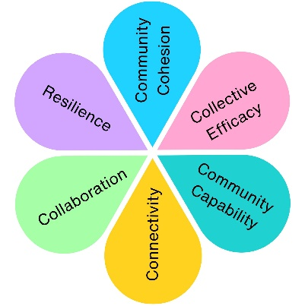
Community Fridge - From COVID Response to Community Asset
The Community Fridge was established as a lasting legacy of the community partnerships and relationships formed during the COVID-19 response. Bringing together local authorities, community organisations, volunteers and businesses, the project aimed to reduce food waste while providing free access to surplus food for local residents. What began as an idea during the pandemic evolved into a community-led initiative that continues to benefit residents today.
The Community Fridge model is used nation wide, but is often adapted to the needs of the local people and the spaces available. This made it challenging to find the right format for Weston-super-Mare. Unlike other community fridges, the Fridge of Free Stuff was set up inside a shopping centre is ‘meanwhile’ units. In order to assess the feasibility of the project in the short term, a six week trial period was run at the end of 2021.
Impact at a glance – 6 week trial
679.68kg
Food Redistributed
1.08 Tonnes
CO2e Saved
1,618
Equivalent Meals Redistributed

Following the initial 6 week trial, the fridge was formally opened in January 2022.
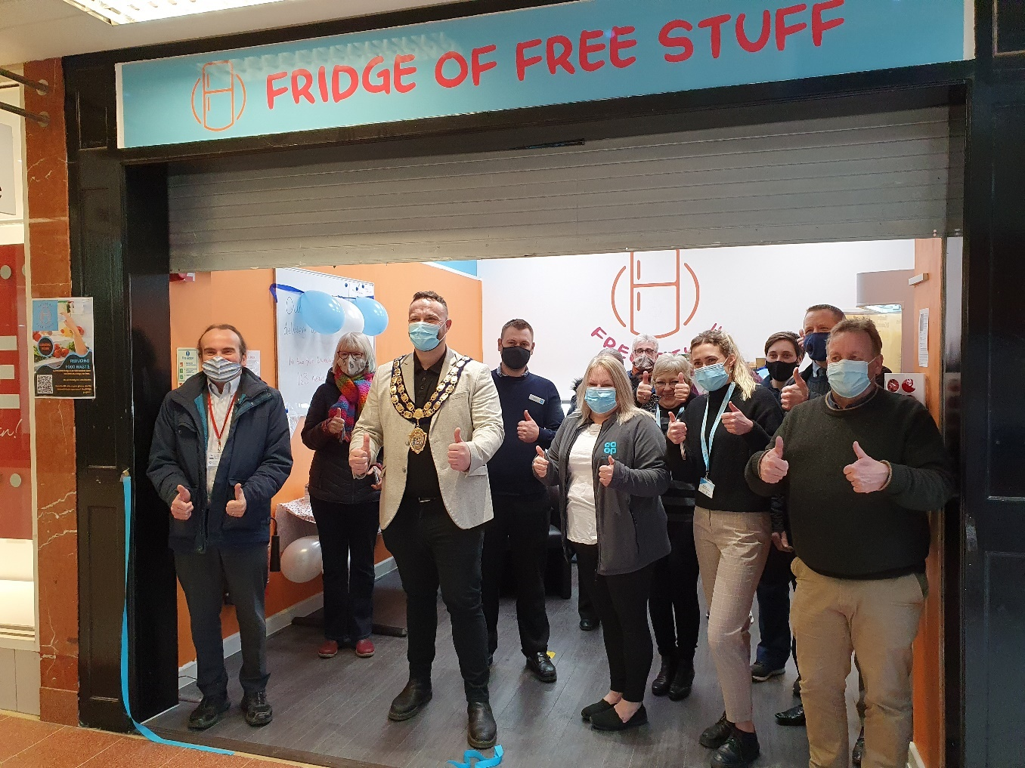
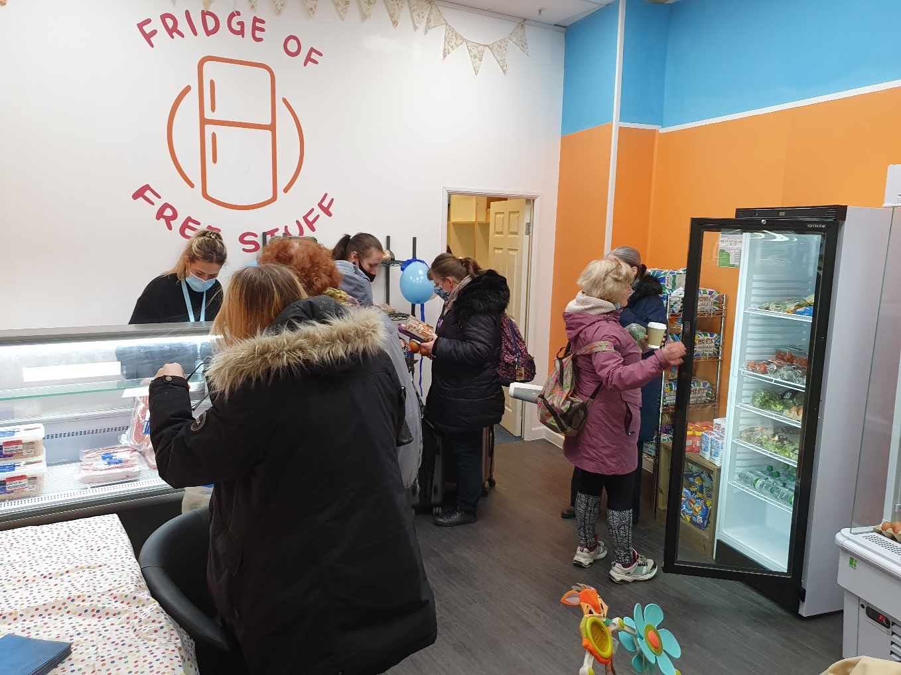
Bringing Communities Together
The Community Fridge relied on collaboration between a wide range of organisations and individuals.

Public Sector
Weston-super-Mare Town Council
North Somerset Council
Community Organisations
For All Healthy Living Centre
Helping People
ROC (earlier delivery model)

Regional Partners
FareShare South West
FoodShare
Community Fridge projects in Frome and Pill
Local Community
Volunteers
Residents
Local businesses donating food

Why Collaboration Matters
No single organisation could deliver the project alone.
The Community Fridge brought together:
Food suppliers
Community groups
Volunteers
Local Authorities
Residents

A Resilient Approach
The project evolved through several phases before reaching its final delivery model.
June 2020 – October 2020
Outdoor Community Fridge Feasibility

January 2021 – June 2021
Indoor Community Fridge Model with ROC

July 2021 Onwards
Indoor Community Fridge operated with For All Healthy Living Centre

What We Learned
When one delivery partner was no longer able to support the project, alternative community partners stepped forward.
This flexibility allowed the project to continue and ultimately succeed.
Powered by Volunteers
The project quickly attracted local volunteers who supported:
- Day-to-day operations
- Food redistribution
- Community awareness
- Informal referrals
Without volunteer support, the project would not have been possible.

More Than Food Redistribution
While reducing food waste was the primary aim, the project delivered wider community benefits.
Building Connections
The project strengthened relationships between organisations and created new opportunities for partnership working.
Creating Awareness
The project generated positive publicity and encouraged discussions around food waste, sustainability and community support.
Supporting Residents
The fridge provided a welcoming space where conversations about food, need and community support could take place.
A Lasting Legacy
The Community Fridge demonstrates how the partnerships created during a crisis can evolve into long-term community assets.

The Difference Community Action Made
The Community Fridge grew from the relationships, trust and community spirit developed during the COVID-19 response. By bringing together volunteers, organisations, businesses and local authorities, the project created a practical solution to food waste while strengthening community connections across Weston-super-Mare.

Impact Assessment
 | Impact Theme | Evidenced? | Project Contribution
 | Physical Health | ✓ | Improved access to food, including fresh produce, can support healthier diets.
 | Mental Wellbeing | ✓ | Reduced food insecurity and increased community support can positively affect wellbeing.
 | Social Inclusion | ✓ | Open-access model creates opportunities for people from different backgrounds to participate without stigma.
 | Community Connection | ✓ | Volunteers, businesses, community groups and residents work together to operate the fridge.
 | Environmental Benefit | ✓ | Redistribution of surplus food prevents waste and supports sustainability goals.
 | Economic Benefit | ✓ | £28,063.33 investment secured. Residents can access free food while businesses reduce food waste disposal costs.
 | Skills & Learning | ✓ | Increased awareness of food waste, sustainability and food-sharing practices.
 | Accessibility & Equality | ✓ | Open access helps ensure food support is available to a broad range of residents.
 | Community Pride | ✓ | Positive community-led initiative developed from local partnerships.

