2021 Community Outcome Round-Up
Community Engagement
The Community Fridge was established as a lasting legacy of the partnerships and community networks created during the COVID-19 response. Working alongside North Somerset Council, For All Healthy Living Centre, local businesses, volunteers and regional food redistribution organisations, Weston Town Council helped create a project that reduces food waste while making surplus food available to the local community.
The project demonstrated the power of collaboration, bringing together public sector organisations, community groups, businesses and volunteers around a shared goal. Despite changes to delivery partners during development, the project adapted and evolved, ultimately opening with strong community support and a dedicated volunteer base. Through word-of-mouth referrals, local partnerships and ongoing community involvement, the Community Fridge quickly became an established community resource and a positive example of how communities can work together to address local challenges.


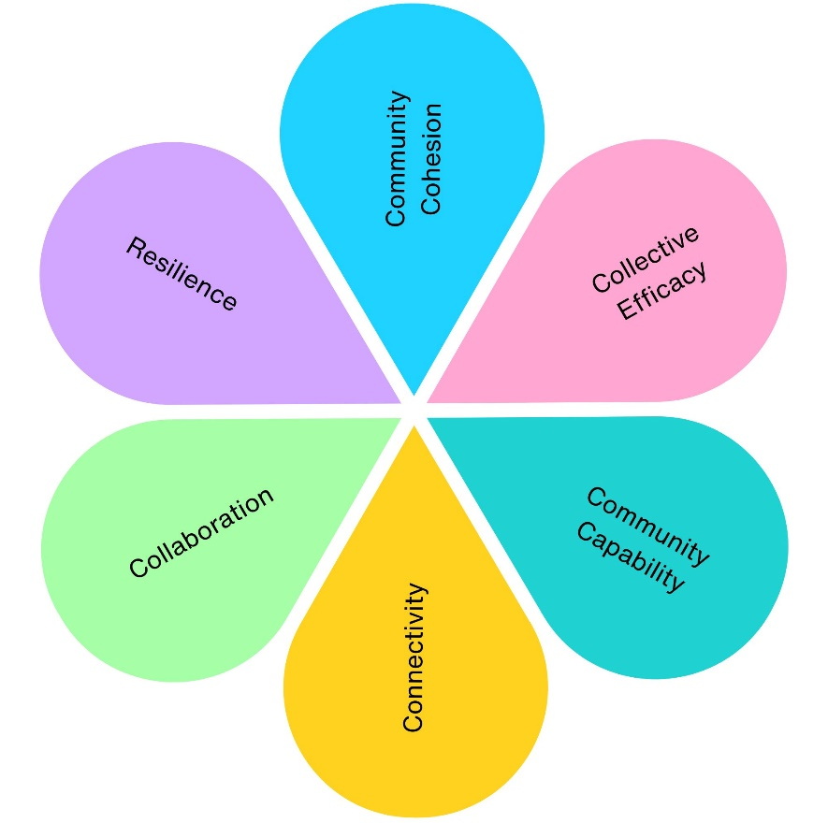
1
1
1
1
1
1

2021 Community Engagement Impact
Across 1 community engagement project, we have contributed to:
- 1 project supporting physical health (Community Fridge)
- 1 project supporting mental wellbeing (Community Fridge)
- 1 project improving social inclusion (Community Fridge)
- 1 project strengthening community connections (Community Fridge)
- 1 project improving environmental outcomes (Community Fridge)
- 1 project delivering economic benefits (Community Fridge)
- 1 project supporting skills and learning (Community Fridge)
- 1 project increasing accessibility and equality (Community Fridge)
- 1 project promoting community pride and participation (Community Fridge)
- 679.68kg of surplus food redistributed during the initial six-week trial
- 1,618 equivalent meals provided to local residents
- 1.08 tonnes of CO₂e emissions prevented through food redistribution
- £28,063.33 external investment secured to establish the project
- 1 volunteer-led community service established, creating a lasting legacy from COVID-19 partnerships
- Over 10 organisations and community partners brought together, including local authorities, voluntary organisations, businesses, regional food redistribution networks and volunteers to deliver the project.

