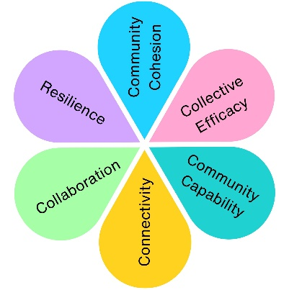
Castle Batch SEND Play Area Refurbishment
Castle Batch was due for refurbishment and the Town Council recognised a lack of accessible and inclusive play provision for children and young people with Special Educational Needs and Disabilities (SEND) across Weston-super-Mare.
The community was invited to help shape a new vision for the site, ensuring the play area reflected the needs of children, families, carers, schools and support organisations.
Impact at a glance
166
Responses from Park users
£200,000
Additional funding obtained
2,140
Children with SEND represented
229
Responses from Parents, Carers and Teachers






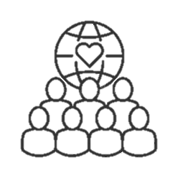
Who We Worked With
Community
Organisations
SEND
Schools
Carers
Children &
Young People
Families
Teachers

Local families, schools, support organisations and community groups were invited to become part of a collaboration of community change-makers, helping to create a much-needed inclusive play area for children and young people with Special Educational Needs and Disabilities. The project aimed to create a flagship facility for Weston-super-Mare and an example of inclusive play that could inspire communities across the UK.

What We Heard
Top Priorities Identified

Accessibility
Families wanted equipment that could be used by wheelchair users and children with a wide range of needs.
Safety
Secure fencing, controlled access and protection from anti-social behaviour were recurring themes.
Inclusion
Families wanted siblings and children of different abilities to be able to play together.
Comfort and Support
Requests included seating, shelter, accessible paths and picnic areas.
Sensory Play
Strong demand for tactile, musical and sensory experiences.

Community Voices
"Please put a wheelchair accessible roundabout so that I can go on it."
"At present the only accessible park is a long drive away which isn't always practical."
"Having SEN and regular equipment alongside each other is great especially for mixed ability families."

You Said, We Did
You said: We need wheelchair accessible equipment
"Anything wheelchair accessible is really appreciated, particularly for older children who cannot easily be lifted."
We did: Installed wheelchair swing, wheelchair roundabout and accessible trampoline

You said: We need sensory experiences
“Maybe sensory equipment, like mirrors and things that make sounds!”
We did: Included tactile stimulation areas, musical panels, sensory equipment and quiet spaces

You said: We need somewhere to retreat when overwhelmed
“It would be great if we could have a quiet area as well.”
We did: Included dedicated quiet retreat spaces and cosy cocoon pods

You said: We want children of different abilities to play together
“Having Sen and regular equipment alongside each other is great especially for mixed ability families.”
We did: Included inclusive swings, roundabouts, seesaws and multi-user equipment

You said: Access can be difficult
“I use a wheelchair and find access at Castlebatch very hard especially in the winter months.”
We did: Added pathways and improved accessibility across the site

The Outcome
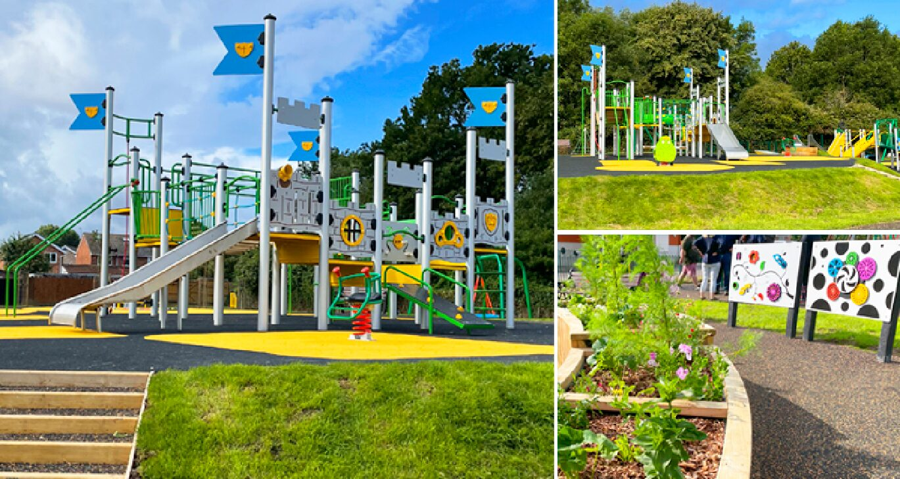
Community-Led Design
The community's feedback directly informed the final £400,000 design, which incorporated virtually every major theme identified during consultation.
What Was Delivered?
Large climbing structures
Multi-play units
Wheelchair swing
Accessible roundabout
Ground-level trampoline
Musical play features
Quiet retreat spaces
Accessible pathways
Accessible seating and picnic areas
Sensory play elements

The Castle Batch Inclusive Play Area demonstrates how community engagement can directly influence the design of public spaces. Families, children, schools and support organisations helped shape a facility that reflects real local needs and creates opportunities for inclusive play for years to come.

Impact Assessment
 | Impact Theme | Evidenced? | Project Contribution
 | Physical Health | ✓ | Inclusive play opportunities created
 | Mental Wellbeing | ✓ | Accessible outdoor recreation provided
 | Social Inclusion | ✓ | Children of different abilities can play together
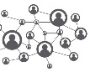 | Community Connection | ✓ | Shared community space created
 | Environmental Benefit | ✓ | Additional Tree planting and inclusion of a sensory garden
 | Economic Benefit | ✓ | £200,000 additional investment secured
 | Skills & Learning | ✓ | Inclusion of Play panels with cognitive function activities, as well as element of risk included within Play to allow children to challenge themselves
 | Accessibility & Equality | ✓ | Barriers to participation reduced
 | Community Pride | ✓ | New flagship community facility created

