2022 Community Outcome Round-Up
Community Conversation Sessions
May 2022 – November 2022: Castle Batch SEND Play Area Refurbishment
In 2022, Weston Town Council began an ambitious project to transform Castle Batch into a flagship inclusive play area for children and young people with Special Educational Needs and Disabilities (SEND). Recognising a lack of accessible play provision locally, the Council invited families, carers, schools, support organisations and existing park users to help shape the design through surveys and community conversations.
The response was overwhelming, with nearly 500 consultation responses received. Residents highlighted the importance of accessible equipment, sensory play opportunities, quiet spaces and facilities that would allow children of all abilities to play together. Their feedback directly influenced the final £400,000 design, which incorporated wheelchair-accessible equipment, sensory play features, inclusive swings and roundabouts, quiet retreat spaces and improved accessibility throughout the site.
The project demonstrates the value of community-led design, ensuring that the finished play area reflects the lived experiences and needs of the families who will use it. By placing community voices at the heart of decision-making, Castle Batch has become more than a refurbished play area—it is a lasting example of how local people can help shape public spaces that are inclusive, welcoming and accessible for everyone.


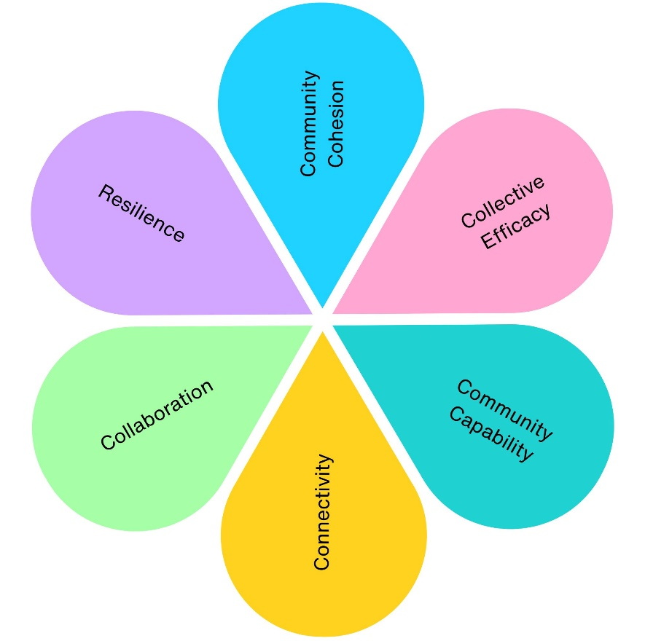
1
1
1
11
1
1

2022 Community Engagement Impact
Across 1 community engagement project, we have contributed to:
- 1 project supporting physical health (Castle Batch SEND Play Area)
- 1 project supporting mental wellbeing (Castle Batch SEND Play Area)
- 1 project improving social inclusion (Castle Batch SEND Play Area)
- 1 project strengthening community connections (Castle Batch SEND Play Area)
- 1 project improving environmental outcomes (Castle Batch SEND Play Area)
- 1 project delivering economic benefits (Castle Batch SEND Play Area)
- 1 project supporting skills and learning (Castle Batch SEND Play Area)
- 1 project increasing accessibility and equality (Castle Batch SEND Play Area)
- 1 project promoting community pride and participation (Castle Batch SEND Play Area)
- 395 community consultation responses collected (166 park users and 229 parents, carers and teachers)
- 2,140 children with SEND represented through engagement with families, schools and support organisations
- £200,000 additional external investment secured, enabling the project budget to double from £200,000 to £400,000
- 1 flagship inclusive play area co-designed with the community
- 10 major community-led design features delivered, including accessible equipment, sensory play, quiet spaces and improved accessibility throughout the site.

