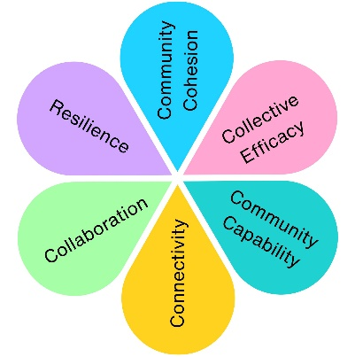
SEND Sessions at Castle Batch
In 2022, local children, families, carers and support organisations helped shape the vision for a new SEND play area. In 2023, pupils from two local SEND schools were invited to experience the completed play area before its official opening, demonstrating the lasting impact of community-led design.
Community Conversations in Action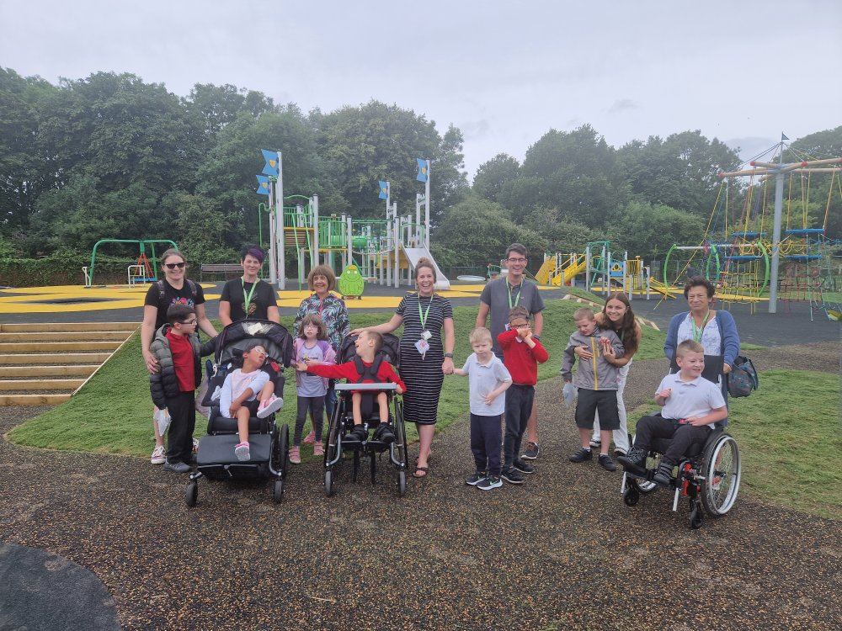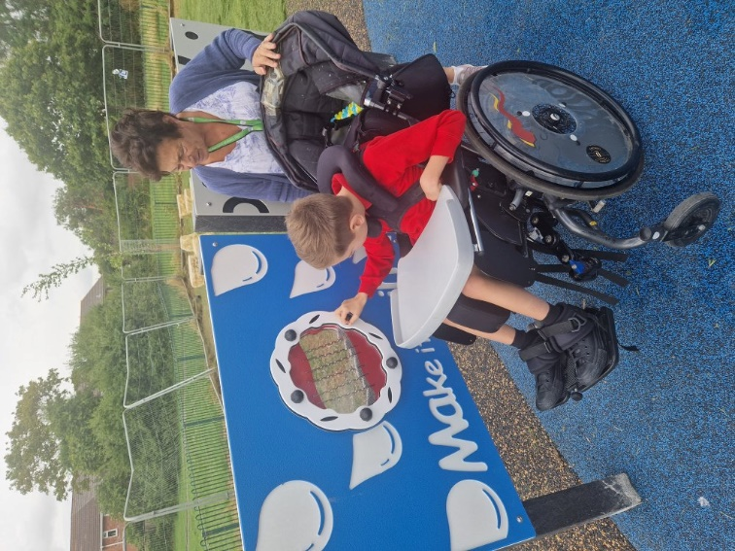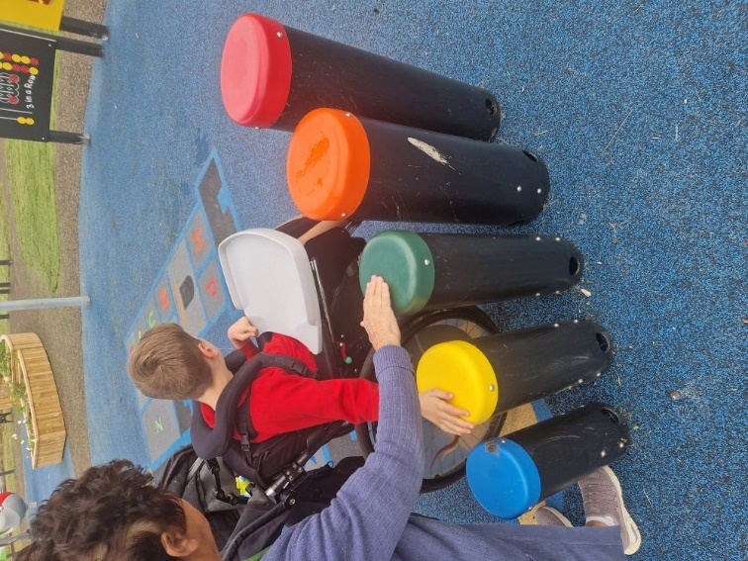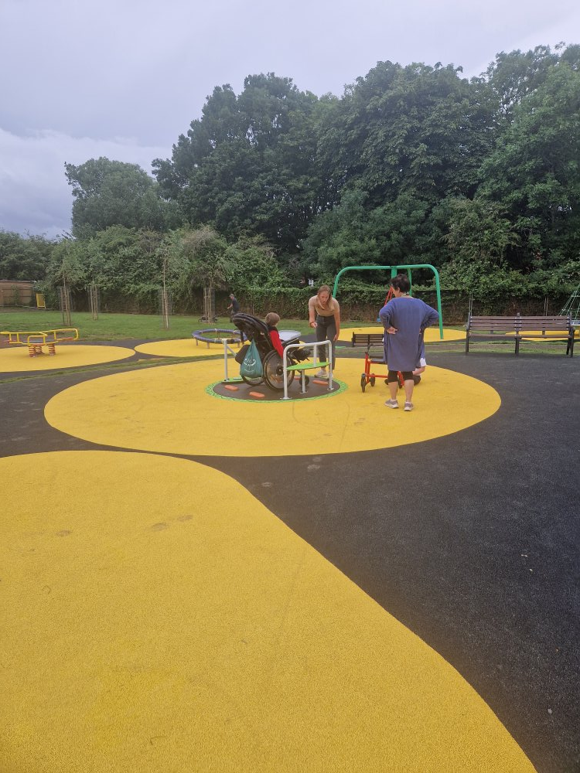
What Changed?
Community feedback helped shape a play area designed to be more inclusive, accessible and enjoyable for children with a range of needs.
Community Input
Design Development
Completed Play Area
Children Using the Space

Why This Matters
Community engagement is most meaningful when people can see the difference their involvement has made. By inviting pupils from local SEND schools to experience the completed play area, we were able to celebrate the contribution of the children, families and organisations whose voices helped shape the project.
This project demonstrates:

✔ Listening to lived experience
✔ Inclusive design in practice
✔ Community influence on public spaces
✔ Long-term impact of community conversations
✔ Accessible play for future generations

Impact Assessment
 | Impact Theme | Evidenced? | Project Contribution
 | Physical Health | ✓ | Children were able to access inclusive outdoor play designed around their needs.
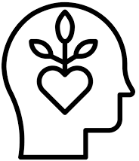 | Mental Wellbeing | ✓ | Positive play experiences supported confidence, enjoyment and wellbeing.
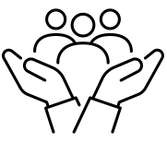 | Social Inclusion | ✓ | Children with complex needs accessed play alongside peers in an inclusive environment.
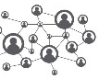 | Community Connection | ✓ | Families, schools and the Council celebrated the completion of a community-designed project.
 | Environmental Benefit
 | Economic Benefit
 | Skills & Learning | ✓ | Demonstrated how lived experience can successfully influence public space design.
 | Accessibility & Equality | ✓ | Community-designed inclusive play equipment removed barriers to participation.
 | Community Pride | ✓ | Showcased the successful delivery of a flagship community project shaped by local people.

