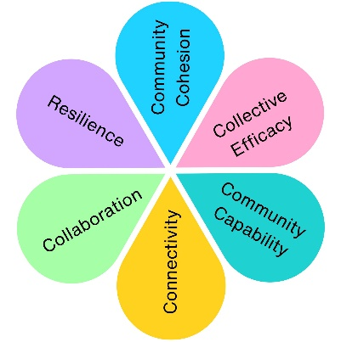
Your Town Your Voice 2023
Your Town Your Voice was launched as Weston Town Council's annual community consultation programme, designed to give residents a direct opportunity to influence Council priorities, service delivery and future budget decisions.
The consultation was structured around the Council's five strategic pillars:
- Weston View
- Cleaner & Greener
- Healthier & Happier
- A Bright Future
- Heritage, Arts & Culture
and combined an online survey with face-to-face community engagement sessions.
Impact at a glance
516
Survey Responses
5
Strategic Pillars Explored
20
Service Areas Reviewed
1
In-person engagement sessions

Top Community Priorities
- Parks and Play Area
- Weston Museum
- Public Toilets
- Climate Emergency
- Youth Services
- CCTV
- Blakehay Theatre
Lowest Ranked Priorities
- Climate emergency
- Remembrance Sunday
- Armed Forces Celebration
- Blue Plaques
- Noticeboards
- Christmas Lights
- Milton Road Cemetery

What We Heard
Key Themes Across All Engagement
Theme | What Residents Told Us
Pride in Local Spaces | Residents consistently valued parks, play areas, public spaces and cultural assets that contribute to the quality of life in Weston
Cleaner and Greener Weston | Strong support was expressed for environmental improvements, parks, floral displays and allotments, alongside calls for better maintenance and communication
Accessible Community Facilities | Public toilets emerged as one of the highest-priority services, demonstrating their importance to residents, visitors and town centre accessibility
Better Communication | A recuring theme across responses was a desire for greater awareness of Council services, events, volunteering opportunities and cultural activities.
Informing Council Decision Making
The consultation was designed to support:
Budget Setting
Medium Term Financial Planning
Service Prioritisation
Strategic Planning
Future Community Engagement Programmes

The findings provided evidence to help guide where investment should continue and where residents felt services delivered the greatest value.

Learning for Future Engagement
The consultation also identified opportunities to strengthen future engagement by:

✔ Increasing participation year-on-year
✔ Reaching younger residents
✔ Engaging more diverse communities
✔ Expanding face-to-face opportunities
✔ Developing smaller, more regular consultations throughout the year

These recommendations directly influenced the future development of the Your Town Your Voice programme.
The Difference Community Voices Made
Your Town Your Voice established a new approach to community engagement in Weston-super-Mare, creating a structured opportunity for residents to influence services, priorities and investment decisions. The consultation provided valuable evidence for strategic planning while helping shape the future evolution of community engagement across the Town Council.
Who Took Part?

Impact Assessment
 | Theme | Evidenced? | Project Contribution
 | Physical Health
 | Mental Wellbeing
 | Social Inclusion | ✓ | Residents were invited to influence priorities across all Council services.
 | Community Connection | ✓ | Created direct dialogue between residents, councillors and officers.
 | Environmental Benefit | ✓ | Community priorities informed future investment in parks, green spaces and environmental services.
 | Economic Benefit | ✓ | Evidence gathered informed budget setting and medium-term financial planning.
 | Skills & Learning | ✓ | Increased public understanding of Council services, priorities and decision-making.
 | Accessibility & Equality | ✓ | Combined online and face-to-face engagement to widen participation.
 | Community Pride | ✓ | Established an annual consultation programme giving residents a direct voice in shaping Weston-super-Mare.

