2023 Community Outcome Round-Up
Community Conversation Sessions
November 2023: Your Town Your Voice
Your Town Your Voice was launched as Weston Town Council's annual community consultation programme, designed to give residents a direct opportunity to influence Council priorities, service delivery and future budget decisions.
The consultation was structured around the Council's five strategic pillars:
- Weston View
- Cleaner & Greener
- Healthier & Happier
- A Bright Future
- Heritage, Arts & Culture
and combined an online survey with face-to-face community engagement sessions.
July 2023: SEND Sessions at Castle Batch
Following a large scale community engagement programme in 2022 to support the development of an SEND play area, we invited two local SEND schools to visit the finished park ahead of its opening. These sessions were attended by children with profound and multiple learning difficulties and enabled them to enjoy the play area that their support and input helped design.



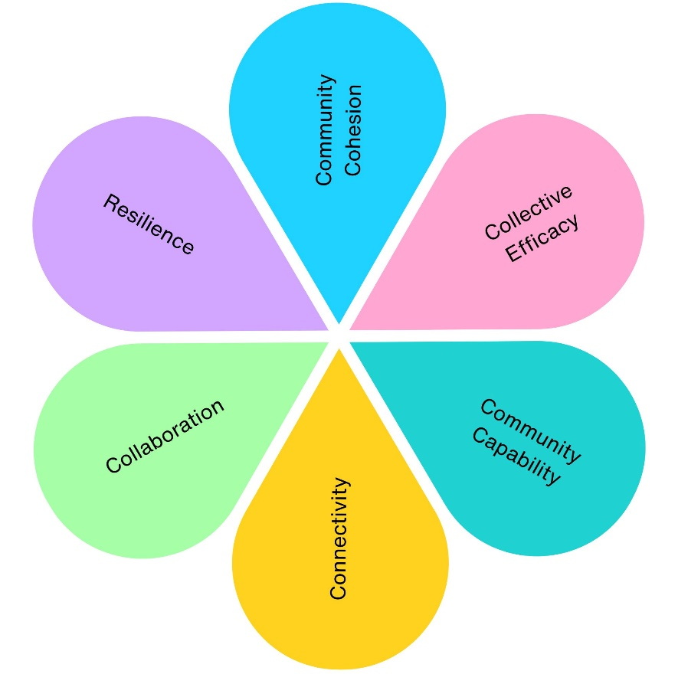
2
2
2
2
2
2

2023 Community Engagement Impact
Across 2 community engagement projects, we have contributed to:
- 1 project supporting physical health (Castle Batch SEND Sessions)
- 1 project supporting mental wellbeing (Castle Batch SEND Sessions)
- 2 projects improving social inclusion (Castle Batch SEND Sessions, Your Town Your Voice)
- 2 projects strengthening community connections (Castle Batch SEND Sessions, Your Town Your Voice)
- 1 project improving environmental outcomes (Your Town Your Voice)
- 1 project delivering economic benefits (Your Town Your Voice)
- 2 projects supporting skills and learning (Castle Batch SEND Sessions, Your Town Your Voice)
- 2 projects increasing accessibility and equality (Castle Batch SEND Sessions, Your Town Your Voice)
- 2 projects promoting community pride and participation (Castle Batch SEND Sessions, Your Town Your Voice)
- 1 community-designed facility demonstrated in use (Castle Batch SEND Sessions)
- 1 annual community engagement programme established, and budget setting influenced (Your Town Your Voice)

