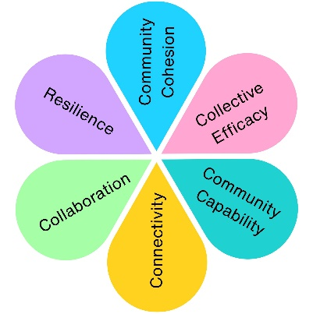
Shaping Places for Healthier Lives
Weston-super-Mare Town Council worked with local food providers, community organisations and residents to better understand food insecurity in Weston Central and Weston South. Through community conversations and a resident survey, local people helped identify barriers to accessing food and shape future priorities for food support.
Key Statistics
81
South and Central Ward Survey Responses
46
Residents worried about eating healthily
49
Residents worried about affording food
61
Residents reported worries about food

What people had to say
"You have to constantly look for the best deals."
"Food costs more, but we seem to get less for our money."
"Healthy food often feels out of reach."

"Extreme anxiety about food. Having to choose between food and bills."
"It's making it hard to budget effectively."
"Feeding my children and myself is really hard."

Key Themes
Affordability
The most common concern was the rising cost of food and the impact of the cost-of-living crisis.

Healthy Eating
Many residents wanted to eat more healthily but felt cost was a barrier
Access
Some residents experienced challenges accessing suitable shops or obtaining food that met their dietary needs.
Practical Barriers
Transport, access to food locally and budgeting support emerged as recurring themes.
Community Support
Residents recognised the importance of local food providers, community organisations and support networks.

Working Together
The project brought together…
Weston-super-Mare Town Council
Weston Foodbank
Purple Sheep Pantry
For All Healthy Living Centre
Alliance Homes
Voluntary Action North Somerset
The Stable CIC
The Other Place

...to explore long-term solutions to food insecurity.




What Made This Approach Different?
Collaboration
Long Term Sustainability
Resident Voices

Community Led Solutions

The Difference Community Conversations Made
Community conversations helped move the discussion beyond emergency food provision and towards understanding the wider causes of food insecurity. Residents, organisations and local partners worked together to identify barriers, share experiences and shape future priorities for food support in Weston-super-Mare.
Community Projects as a result of the Consultation
The Other Place Community Culinary Empowerment
In person group cooking confidents building sessions to help increase knowledge and understanding of food.

The Stable CIC Food Boxes
Supported young people with food boxes and recipe cards to increase food diversity within diets and knowledge.

Alliance Homes / Purple Sheep Food Pantry
Pop up pantry in South Ward at the alliance homes hub. Supplying food for low cost to local residents
5.2

Impact Assessment
 | Impact Theme | Evidenced? | Project Contribution
 | Physical Health | ✓ | Helped identify barriers to healthier eating and improved access to nutritious food.
 | Mental Wellbeing | ✓ | Increased understanding of food insecurity and its impact on residents' wellbeing.
 | Social Inclusion | ✓ | Residents and organisations worked together to shape future food support priorities.
 | Community Connection | ✓ | Strengthened partnerships between local organisations and community groups.
 | Environmental Benefit | ✓ | Encouraged sustainable, community-led approaches to local food provision.
 | Economic Benefit | ✓ | Supported affordable food initiatives that help reduce financial pressures on residents.
 | Skills & Learning | ✓ | Improved knowledge around healthy eating, budgeting and food preparation.
 | Accessibility & Equality | ✓ | Identified barriers to accessing food and informed more inclusive support services.
 | Community Pride | ✓ | Enabled residents to shape long-term solutions for their community.

