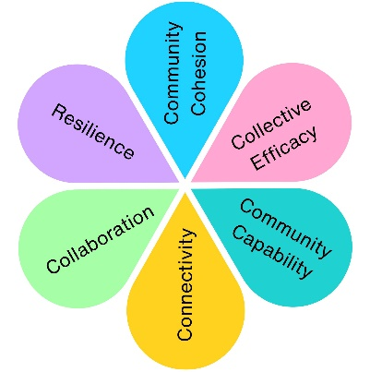
Christmas Lights
To help shape the future of Weston's Christmas lights display, the Town Council invited residents to share their ideas through a public survey and face-to-face conversations at the EAT Festival, Italian Gardens and Winter Gardens. The feedback gathered helped inform the procurement of a new Christmas lights contract and ensure the display reflected community aspirations.
Impact at a glance
166
Survey Responses
1
EAT Festival community engagement

Community feedback directly informed the contract specification

You Said, We Did
You Said: We want a traditional design and switch on event
“Traditional bulb colour yellow/white”
“Traditional Victorian. It appears more ‘classy’. Be more Bath, not Blackpool.”
“Like the traditional colours. Reds, greens, whites.”
“Traditional Christmas markets, something different every weekend live music”
“A traditional theme would be interesting especially if all the retailers agreed to match the theme’ing”
“Traditional Christmas and Nativity as most children will do a nativity story and be familiar with it”
We Did: chose a design which used traditional colours, and held a switch on event with entertainment like a brass band

You Said: Its important to have a tree

We Did: Chosen design centred around a landmark tree

Create Festive Cheer
Residents felt the Christmas lights play an important role in bringing people together and creating a festive atmosphere across the town.

Feel Traditional but Fresh
Traditional Christmas displays remained the most popular choice, but many residents also welcomed modern features and interactive elements.

Reflect Weston’s Identity
Residents wanted displays that celebrate Weston-super-Mare's seaside character, heritage and landmarks.
Reach More Areas of Town
Many people felt the displays should extend beyond the High Street and showcase more parts of Weston.
Are Sustainable
Energy efficiency and environmentally friendly lighting were identified as important considerations.

Chosen Design
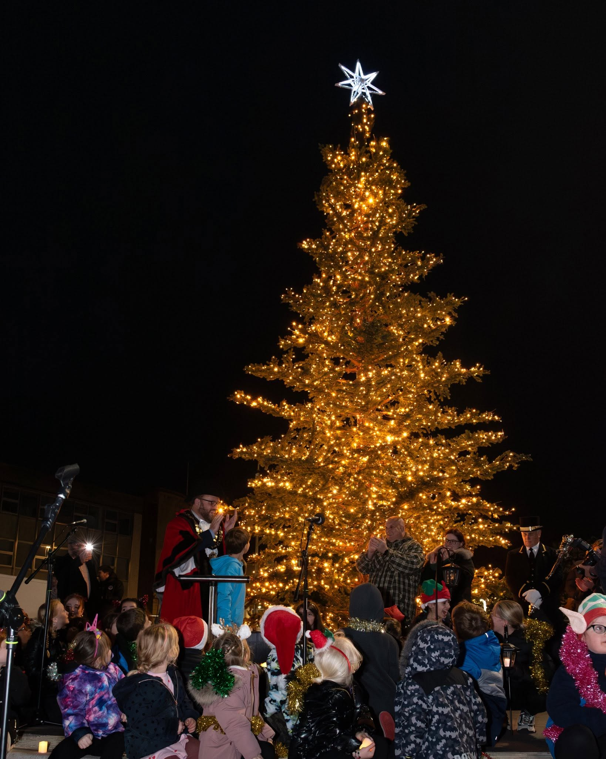
Community feedback helped shape a Christmas lights programme that balances tradition and innovation, celebrates Weston-super-Mare's unique identity and creates a welcoming festive experience for residents and visitors alike.

Impact Assessment
 | Impact Theme | Evidenced? | Project Contribution
 | Physical Health
 | Mental Wellbeing | ✓ | Creates welcoming public spaces that encourage enjoyment and festive wellbeing.
 | Social Inclusion | ✓ | Residents helped shape a town-wide event for the whole community.
 | Community Connection | ✓ | Community conversations informed a shared celebration enjoyed by residents and visitors.
 | Environmental Benefit | ✓ | Community feedback encouraged consideration of sustainable lighting and energy efficiency.
 | Economic Benefit | ✓ | Community-informed improvements support the town centre and visitor economy.
 | Skills & Learning | ✓ | Residents increased understanding of how public feedback shapes Council procurement.
 | Accessibility & Equality
 | Community Pride | ✓ | Celebrated Weston-super-Mare's identity through a community-designed Christmas display.

