2024 Community Outcome Round-Up
Community Conversation Sessions
June 2024 – January 2025: The Old Town Quarry Refurbishment Project
Funded by the Community Ownership Fund, with the aim of getting the site back into community ownership. The decision was made to host a series of ‘community conversations’, to invite people in and understand how they felt the site should be used and run. There were in person sessions, which evolved into community charter meetings for the residents of the quarry. There was also a branding survey circulated to help develop the brand.
December 2023 – February 2024: Food surveys for Shaping Places
As part of a grant-funded project addressing the cost-of-living crisis, community feedback was gathered to understand which food-related projects would be most useful locally. Funding was available for a range of initiatives, which needed to be shaped by community need.
November 2023 – March 2024: Christmas lights 2024
a survey and engagement exercise to support the procurement of a Christmas lights company for the Christmas Lights Contract. This included a survey and a mass staff presence at the EAT Festival on the Italian Gardens and in the Winter Gardens.

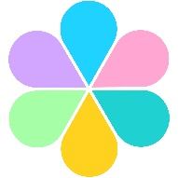

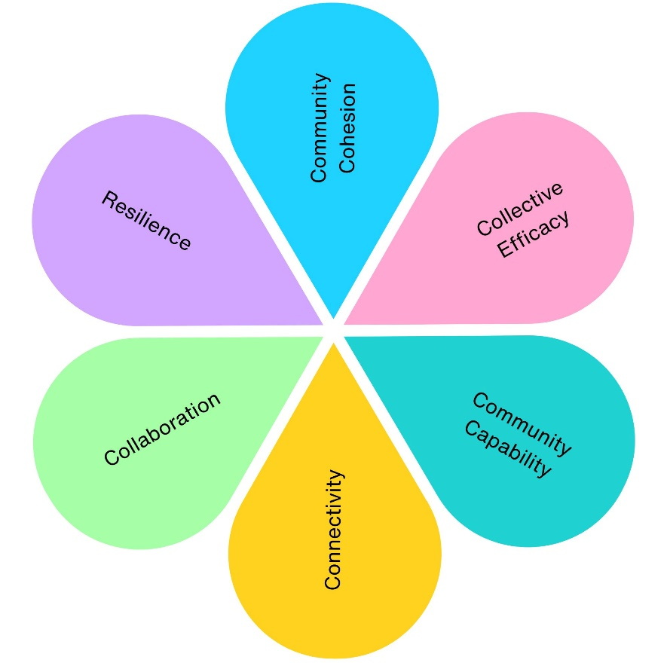
2
3
3
2
2
2

2024 Community Engagement Impact
Across 3 community engagement projects, we have contributed to:
- 2 projects supporting physical health (Old Town Quarry, Shaping Places for Healthier Lives)
- 3 projects supporting mental wellbeing (Christmas Lights, Old Town Quarry, Shaping Places for Healthier Lives)
- 3 projects improving social inclusion (Christmas Lights, Old Town Quarry, Shaping Places for Healthier Lives)
- 3 projects strengthening community connections (Christmas Lights, Old Town Quarry, Shaping Places for Healthier Lives)
- 3 projects improving environmental outcomes (Christmas Lights, Old Town Quarry, Shaping Places for Healthier Lives)
- 3 projects delivering economic benefits (Christmas Lights, Old Town Quarry, Shaping Places for Healthier Lives)
- 3 projects supporting skills and learning (Christmas Lights, Old Town Quarry, Shaping Places for Healthier Lives)
- 2 projects increasing accessibility and equality (Old Town Quarry, Shaping Places for Healthier Lives)
- 3 projects promoting community pride and participation (Christmas Lights, Old Town Quarry, Shaping Places for Healthier Lives)
- 1 community asset returned to community ownership (Old Town Quarry)
- 1 long-term community governance model established (Monthly Community Charter meetings for Old Town Quarry)
- 1 Christmas lights programme redesigned using community feedback (Christmas Lights)
- 3 new community food initiatives developed through partnership working (Shaping Places for Healthier Lives)

