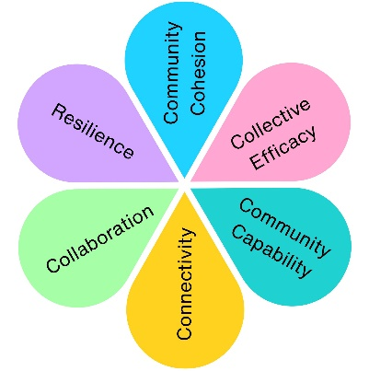
Old Town Quarry Refurbishment Project

Funded through the Community Ownership Fund, the Old Town Quarry Refurbishment Project aimed to bring the site back into community ownership. Through a series of "Quarry Conversations", residents were invited to help shape how the site should be used, managed and programmed in the future.
Impact at a Glance
4
Community Engagement Phases
7
Quarry ‘Conversations’, Opportunities and ‘Focus Group’ Sessions
1
Branding Survey
Monthly
Community Charter Meetings Established

The Quarry Conversations were designed to give local people an opportunity to help shape the future of the site. As discussions evolved, clear priorities began to emerge, providing valuable insight into how the community would like to see the Quarry used, managed and enjoyed in the future.

What We Heard

Arts & Culture
Creative activities, artist involvement and cultural programming.
Environmental Conservation & Wildlife Protection
Protecting habitats, biodiversity and the site's natural character.

Balanced Event Programming
Events that support community use while respecting the ecology of the site.
Education & Learning
A new theme that emerged directly from community conversations.

Residents didn't just want to be consulted on the Quarry's future. They wanted to actively contribute ideas, skills and opportunities to help make it happen.

From Conversation to Action
Phase 3
Quarry Opportunities
Residents submitted ideas, projects and offers of support.

Phase 4
Focus Groups
Ideas were developed into practical proposals with clear delivery plans.

Phase 1
Introducing the project
Community informed about:
- Community Ownership Fund
- Site constraints
- Future opportunities

Phase 2
Quarry Conversations
Residents identified key priorities and shaped the vision for the site.

Outcome
A community-informed operational model and first-year programme were created.

What Changed?

✔ Community priorities identified
✔ New education and learning theme emerged
✔ Residents submitted project ideas and offers of support
✔ First-year operational programme created
✔ Community Charter meetings established
✔ Ongoing community involvement embedded into site management

Community-Led Future
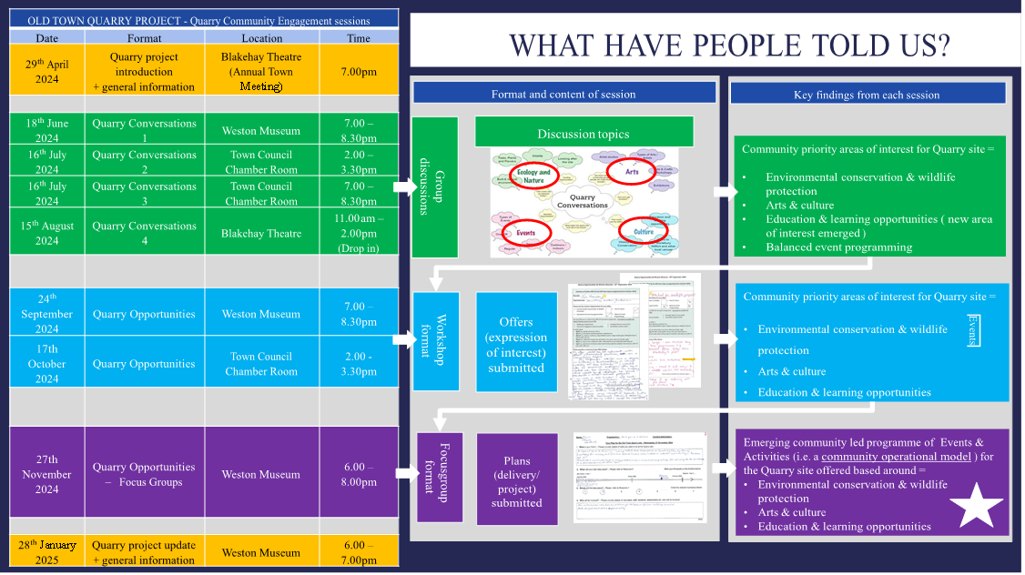
Schedule of Meetings and community outcomes

Impact Assessment
 | Impact Theme | Evidenced? | Project Contribution
 | Physical Health | ✓ | Future plans included activities encouraging outdoor recreation and healthy lifestyles.
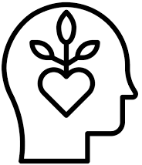 | Mental Wellbeing | ✓ | Increased opportunities for residents to connect with nature, culture and outdoor spaces.
 | Social Inclusion | ✓ | Residents helped shape how the Quarry will be used by the whole community.
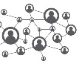 | Community Connection | ✓ | Long-term community involvement embedded into site management.
 | Environmental Benefit | ✓ | Community priorities focused on protecting wildlife, habitats and the natural environment.
 | Economic Benefit | ✓ | Community ownership supports sustainable use of a significant local asset.
 | Skills & Learning | ✓ | Education and learning became a new community priority through engagement.
 | Accessibility & Equality | ✓ | Community-led planning sought to create opportunities for a broad range of users.
 | Community Pride | ✓ | Returned a valued community asset to community ownership and stewardship.

