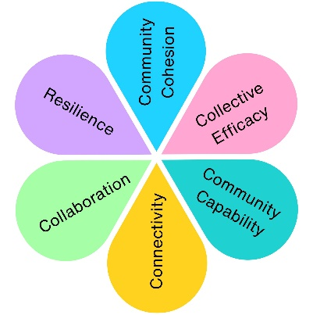
Coniston Green Toddler Play Area Refurbishment
- Pre Build Community Engagement – November 2025
Two online surveys were created to support the procurement of a contract for the Coniston Green Toddler Play Area Refurbishment.
A South Ward Day of Action also took place, during which the Development Team and Grounds Manager supported a wider community initiative. Surveys were distributed through local organisations, and door-to-door engagement took place, with a particular focus on what the community would like to see in the new play area.
You Said, We Did

You said: Play should be for everyone
“Accessible sturdy equipment”
We did: Designed inclusive equipment for all abilities

You said: Kids learn through play
“like connect 4 and puzzle mazes”
We did: Added sensory and interactive play features

You said: Parents need to supervise easily
“The area needs a clean up! ….. and more benches”
We did: Improved layout, visibility and seating areas

You said: Make it more colourful and educational
“I like bright colours”
We did: Used colourful wet pour to enhance the design

You said: Add play value
“the value to play for today’s kids need to be met”
We did: the final design has over 55 individual play values.

Chosen Play Area Design
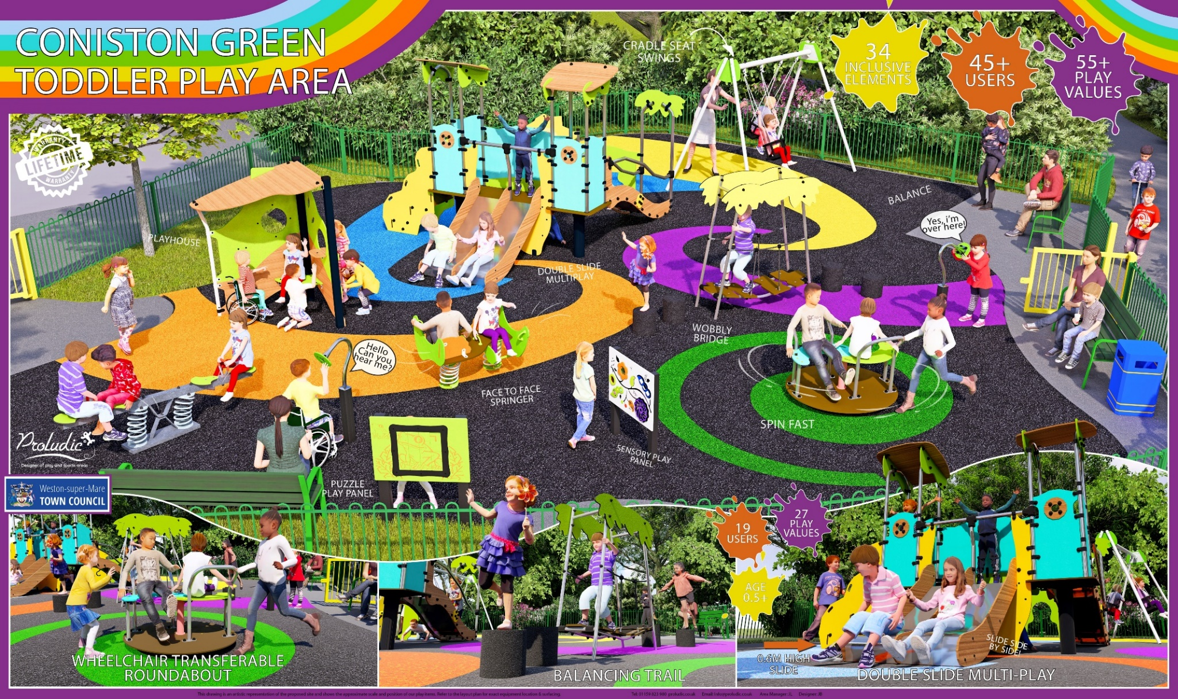

- Play Area Reopening Event
Following the completion of the play area build, a grand opening was held on the 25th July 2026 in order to introduce the community to the new space.
We had some wonderful comment from both users and parents/carers, both in person and online:
Great to have dedicated toddler space
Love the new play area!
Love the new play area. Would like to see improvements in other areas too like Jubilee. In particular bits for older and younger kids – like at Castle Batch.

We also made sure to listen to feedback for improvement at the site, and recommended action where appropriate.
Suggestions | Actions
Bins in the main park | Agreed to install a bin in the park
Move the bench back into a more shaded area | Agreed to put an additional bench in the shade within the play area, and explore planting a tree for more shade.
At a Glance:
In order to gain feedback on the site, we asked the children to rate the space using a smiley face system:
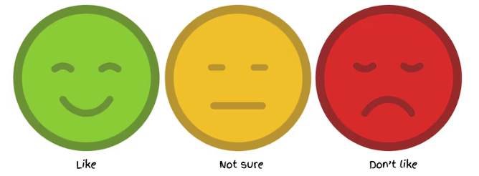
14 | 0 | 0

Impact Assessment
 | Impact Theme | Evidenced? | Project Contribution
 | Physical Health | ✓ | Encourages active play and physical development for young children.
 | Mental Wellbeing | ✓ | Creates enjoyable outdoor play opportunities that support confidence and wellbeing.
 | Social Inclusion | ✓ | Inclusive play features enable children of different abilities to play together.
 | Community Connection | ✓ | Local residents directly influenced the design of a shared community space.
 | Environmental Benefit | ✓ | Refurbished an existing community asset, extending its lifespan and encouraging greater use of local green space.
 | Economic Benefit | ✓ | Community feedback informed investment into a play area that better meets local needs.
 | Skills & Learning | ✓ | Interactive play panels and varied play experiences support learning, creativity and cognitive development.
 | Accessibility & Equality | ✓ | Inclusive equipment and improved layout reduce barriers to participation.
 | Community Pride | ✓ | Refurbished a well-used local play area that reflects community priorities.

