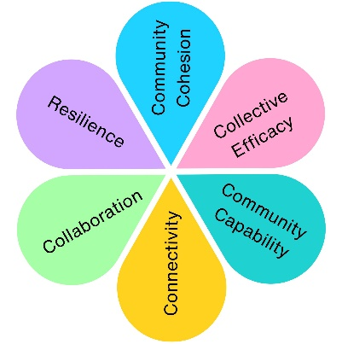
Maltlands Play Area Refurbishment
- Pre Build Community Engagement – November 2025
Two online surveys were created to support the procurement of a contract for the Maltlands Play Area Refurbishment.
You Said, We Did

You said: There’s nothing for toddlers
“More for babies/young toddlers please”
“Play areas in Weston do not accommodate toddlers”
“A climbing frame that is climbable for a 3 year old”
“Although I don't have younger children now there is not climbing equipment for them in this park which is a real shame”
“The Maltlands park has had all of it’s baby/infant play structure and slide removed, so apart from swings, there is nothing for those age 2 and under so I would like to see something back for them”
We did: Added dedicated early years play equipment

You said: We want more climbing and active play
“I like bouncing”
“A climbing frame with slides bridges and tunnels”
“Climbing frame up to a tube slide”
“a lot more sport related equipment would be good like climbing frames and what you call trim trails”
“A mini climbing frame with a little slide, a seesaw, trampolines in the ground, swings, balance equipment”
We did: Made climbing, balancing & movement the heart of the design

You said: There should be something for all ages
“To be honest the park needs more play equipment not just for bigger kids but for the babies and toddlers too”
“The climbing frame could do with updating with easier monkey bars for all ages”
“I think the age group my eldest son is in 8+ really needs more provision for play which reflects their age and ability.”
“We need an assortment of play equipment suitable for different ages. It would be good if it was zoned into age appropriate areas”
We did: Created zones for different age groups to play together

You said: We need places to sit and stay longer
“We would like to see picnic benches in some of the green spaces so we could stay longer.”
“Benches inside the play area for parents would be welcomed.”
“There are currently only 2 benches, more seating would be nice.”
We did: Added seating and space for families to relax

You said: Make better use of the space
“They took away play equipment a d never replaced “
“Playground needs refurbishment and updating. Play equipment has been removed but has never been replaced. This play area would benefit from some themed play equipment and some more play equipment in general.”
We did: Redesigned the layout to open up play and social areas

You said: Some of the existing equipment is well loved”
“The slide already there is decent so I wouldn't add another”
We did: Retained equipment and found new ways to link it in with new exciting concepts

Chosen Play Area Design
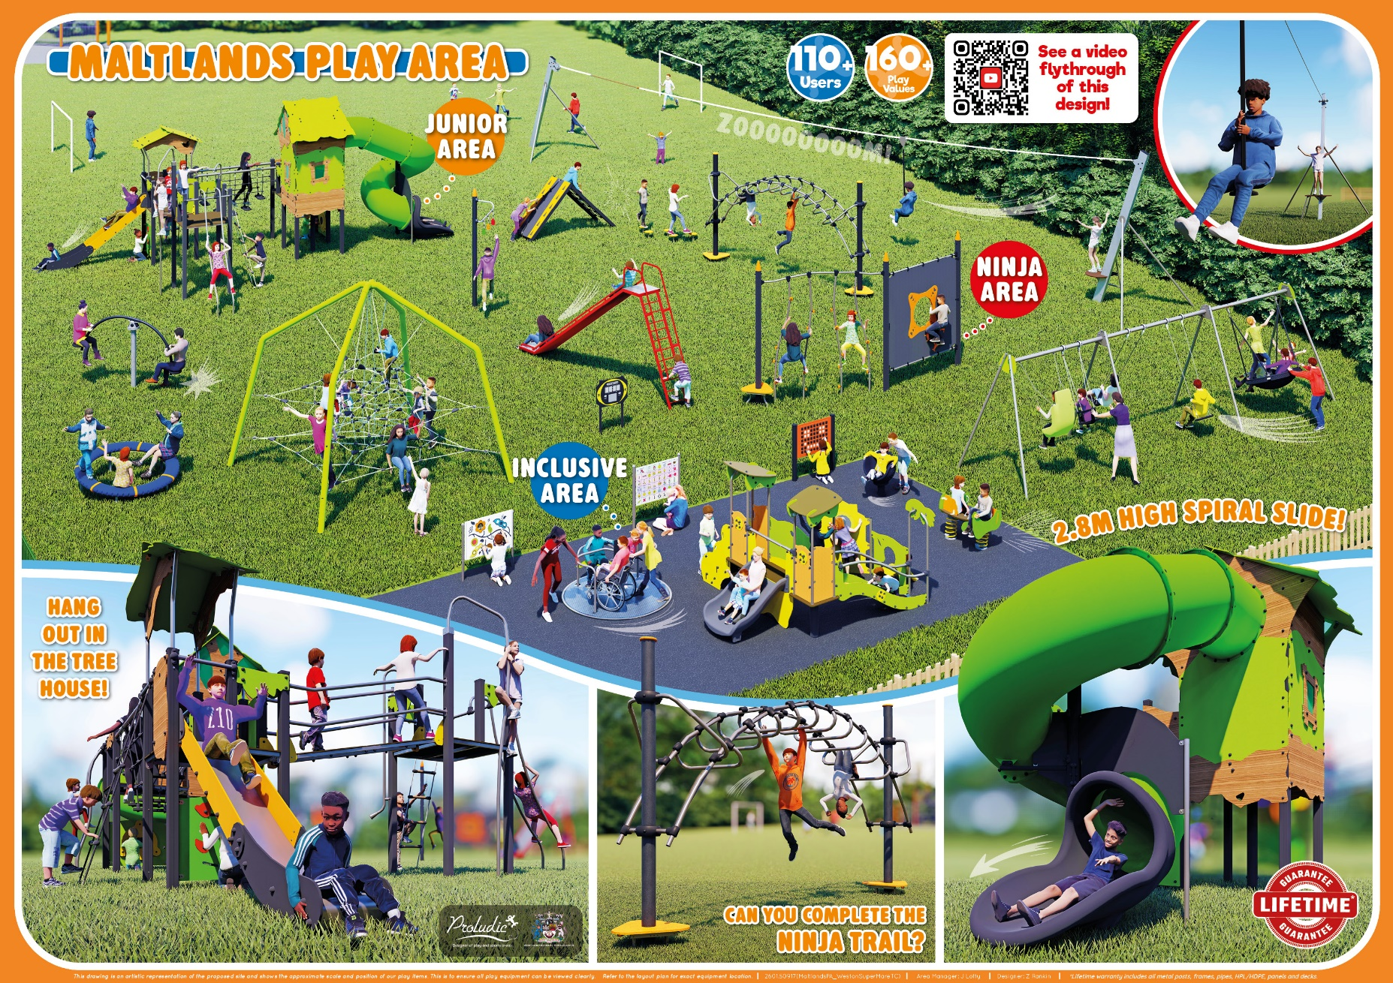

- Play Area Reopening Event
Following the completion of the play area build, a grand opening was held on the 25th July 2026 in order to introduce the community to the new space.
We had some wonderful comment from both users and parents/carers, both in person and online:
“We popped over to the Maltlands park this afternoon with our 1 year old, she used to only be able to go on the swing, but today she was on the climbing frame thing walking along it, going down the slide and up and down the steps either side. Not often I praise the council but you've done a great job with it. It was busy but there was something for everyone”

“Good… Love…lots more to do…10/10” ages 7&10

“The new Maltlands park is brilliant, kids loved it and open just in time for the summer holidays”

“This park is absolutely amazing, You have catered for a range of children's needs and abilities. So much care and attention have gone into creating such a fun and exciting space for the community - thank you”

“like – so much more equipment, with good range of ages covered”

“not visited for years as it was run down. Its brilliant – so much more equipment for all ages. Big slide stayed and the whole area is now used.”

“Variety of things to do, next to an open space – quality”

“fabulous space, much improved. So much more than was their before”
“great – big improvement. Bits for everyone with good age range. Brilliant that we don’t need to go to Castle Batch.”

“I’ve been a resident here for 22 years – very much welcomed, can now visit with Grandchildren.”

“its my local park – much better now its bee upgraded. Toddler area in particular is great. keep doing more like this and Castle Batch – it stands out!”

“resident for nearly 30 years – to see this now is amazing. I watched the build. I hope we are able to keep it nice”

“great/brilliant, hope it isn’t damaged”

“lots more to do, and covered age range well”

“great park – definitely needed.”

“much better, more equipment, more selection”

We also made sure to listen to feedback for improvement at the site, and recommended action where appropriate.
Suggestions | Actions
Toilets | Not feasible at this stage – cost prohibitive
Water features / Sensory play | Will consider as part of future redevelopment
Rubbish and litter picking – how do we educate? | Have provided contact information to the individual who currently carries out litter picking of the site, but sometimes struggles with disposal of larger items (e.g. trolleys). Have agreed to work with them to keep the site clean.
CCTV to keep the site safe and free of anti-social behaviour | To be explored with North Somerset Council
Fence/nets behind the goals | Grounds Team obtaining quotes
Fence around toddler area to prevent children running into path of the swings | Grounds Team obtaining Quotes
Seating for parents/grandparents | Grounds Team obtaining Quotes
MUGA (Multi Use Games Area) flooring needs replacing | Agreed to explore Autumn 2026.
At a Glance:
In order to gain feedback on the site, we asked the children to rate the space using a smiley face system:
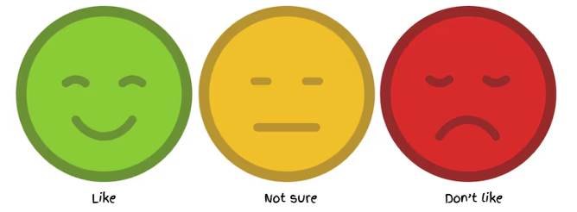
34 | 0 | 0

Impact Assessment
 | Impact Theme | Evidenced? | Project Contribution
 | Physical Health | ✓ | Encourages active play and physical development for children of all ages.
 | Mental Wellbeing | ✓ | Creates enjoyable outdoor play opportunities that support confidence and wellbeing.
 | Social Inclusion | ✓ | Provides play opportunities for toddlers, younger children and older children within the same shared space.
 | Community Connection | ✓ | Local residents directly influenced the design of a shared community space.
 | Environmental Benefit | ✓ | Refurbished an existing community asset, encouraging greater use of local green space.
 | Economic Benefit | ✓ | Community feedback informed investment into a play area that better meets local needs.
 | Skills & Learning | ✓ | Challenging and interactive play equipment supports learning, creativity and problem-solving through play.
 | Accessibility & Equality | ✓ | Inclusive play features and age-appropriate zones create opportunities for children with different needs and abilities.
 | Community Pride | ✓ | Refurbished a valued local play area that reflects community priorities.

