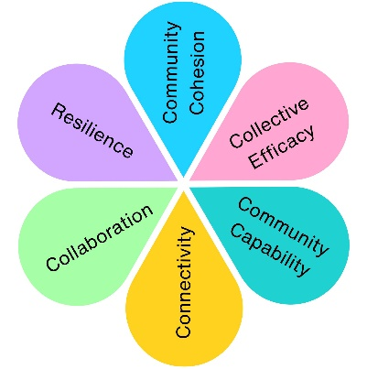
Your Town Your Voice
Your Town Your Voice 2025 combined four seasonal surveys and two community engagement sessions to understand resident priorities and inform budget setting and strategic planning. A total of 467 survey responses and 26 in-person participants contributed to the consultation.
Impact at a glance
5
Strategic Pillars Explored
20
Service Areas Reviewed
2
In-person engagement sessions
467
Survey Responses

Top Community Priorities
- Parks & Play Areas
- Public Toilets
- Weston Museum
- Dog Waste Bins
- Visit Weston
- Blakehay Theatre
- Visitor Information Centre
Lowest Ranked Priorities
- Blue Plaques
- Milton Road Cemetery
- Armed Forces Celebration
- Climate Emergency
- Weston in Bloom
- Remembrance Sunday
- Noticeboards

What We Heard
Key Themes Across All Engagement
Theme | What Residents Told Us
Communication | Residents consistently reported low awareness of services, events and opportunities.
Community Facilities | Parks, toilets and public spaces remain highly valued.
Youth Services | Strong demand for more youth activities and safe spaces.
Culture & Events | Strong support for events, museums and arts activity.
Local Democracy | Limited understanding of councillor roles and council processes.
Community Wellbeing | Wellbeing services are valued but not widely known about.
Maintenance & Cleanliness | Residents expect well-maintained public assets and cleaner streets.

“[Civic Events] Helps with the pride of the Town”
“Consistency in communication is important”
“more advertising is needed to show what events are on so it is used more & more profitable”

“More investment in youth services is needed to engage young people and help reduce antisocial behaviour.”
“I think the Young Services need to encourage younger people to volunteer in the community more”
“[Community Events] I think bringing people together definitely helps reduce loneliness and isolation. Gives pride in our community. Encourage tourists.”

Pillar | Key Findings
Weston View | Residents value tourism, CCTV and visitor services but want better promotion and clearer communication.
Cleaner & Greener | Parks highly valued; support for floral displays, environmental initiatives and cleaner streets.
Healthier & Happier | Youth services and wellbeing strongly supported, but awareness is low.
A Bright Future | Residents want greater understanding of local democracy and councillor visibility.
Heritage, Arts & Culture | Museum, Blakehay Theatre and events highly valued but under-promoted.
The strongest recurring theme across almost every service area was a need for improved communication, promotion and public awareness.

Who Took Part?

Impact Assessment
 | Impact Theme | Evidenced? | Project Contribution
 | Physical Health
 | Mental Wellbeing
 | Social Inclusion | ✓ | Opportunity for residents to participate and shape priorities.
 | Community Connection | ✓ | Direct dialogue between residents, councillors and officers.
 | Environmental Benefit
 | Economic Benefit | ✓ | Informed budget setting, but no direct economic outcome.
 | Skills & Learning | ✓ | Increased awareness of Council services and decision-making.
 | Accessibility & Equality
 | Community Pride | ✓ | Residents influenced the future direction of the town.

