2025 Community Outcome Round-Up
Community Conversation Sessions
November 2025 - Your Town Your Voice Budget Consultation
Budget consultation was carried out ahead of the new 2026-2027 budget being agreed. Two community conversations took place (day time and evening session) to talk members of the public through the proposed budget and get their feedback on priorities. To support this, four seasonal surveys were run throughout the year to capture the budget aspirations in line with the Town Council Strategy.
November 2025 – Coniston Green Toddler Play Area refurbishment
Two online surveys were created to support the procurement of a contract for the Coniston Green Toddler Play Area Refurbishment. A South Ward Day of Action also took place, during which the Development Team and Grounds Manager supported a wider community initiative. Surveys were distributed through local organisations, and door-to-door engagement took place, with a particular focus on what the community would like to see in the new play area.
November 2025 - Maltlands Play Area refurbishment
Two online surveys were created to support the procurement of a contract for the Maltlands Play Area Refurbishment
June 2025 – August 2025: Council of Sanctuary
A motion passed by Council to become a Council of Sanctuary generated significant public concern. In response, two in-person engagement sessions and an online survey were held to understand public opinion. Feedback from these sessions and the survey was reported to a Council of Sanctuary working group made up of councillors. As a result of this engagement, the decision was made to overturn the motion. Over the two-month period, 531 responses were collected, and all in-person sessions reached capacity.



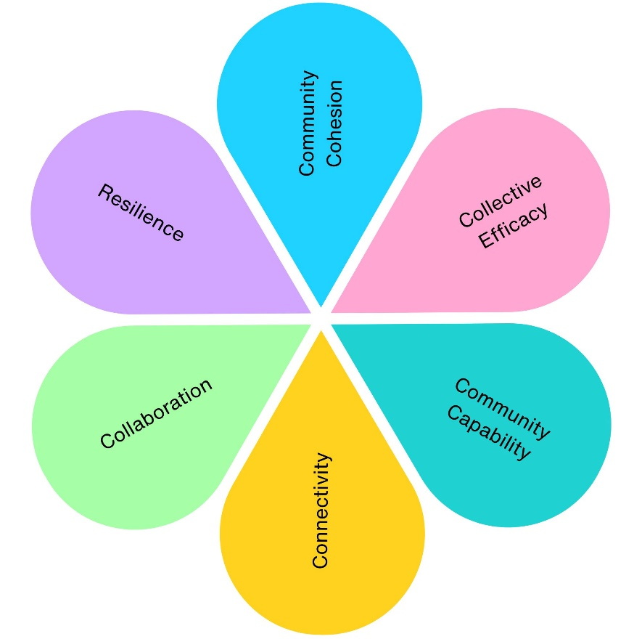
4
1
1
1
2
3

2025 Community Engagement Impact
Across 4 community engagement projects, we have contributed to:
- 2 projects supporting physical health (Coniston Green, Maltlands Play Area)
- 2 projects supporting mental wellbeing (Coniston Green, Maltlands Play Area)
- 4 projects improving social inclusion (Coniston Green, Maltlands Play Area, Your Town Your Voice, Council of Sanctuary)
- 4 projects strengthening community connections (Coniston Green, Maltlands Play Area, Your Town Your Voice, Council of Sanctuary)
- 4 projects supporting skills and learning (Coniston Green, Maltlands Play Area, Your Town Your Voice, Council of Sanctuary)
- 2 projects delivering economic benefits (Coniston Green, Maltlands Play Area)
- 2 projects improving environmental outcomes (Coniston Green, Maltlands Play Area)
- 2 projects increasing accessibility and equality (Coniston Green, Maltlands Play Area)
- 4 projects promoting community pride and participation (Coniston Green, Maltlands Play Area, Your Town Your Voice, Council of Sanctuary)
- 2 community assets improved (Coniston Green Toddler Play Area, Maltlands Play Area)
- 2 play areas redesigned using community feedback (Coniston Green, Maltlands Play Area)
- 1 Council decision directly influenced by community engagement (Council of Sanctuary)
- 1 annual budget informed by community priorities (Your Town Your Voice)

